We are time travellers
The Ancient Egyptians
Holt Class

As Historians, we will be looking at the topic of the Ancient Egyptians. During the next term we will be looking at the achievements of this ancient civilisation. We will learn about how and where the ancient Egyptians lived, what was important to the daily lives of ancient Egyptians, who Tutankhamun was and how mummies were made. We will also learn about how Egyptian people used hieroglyphs to communicate and compare the powers of different gods.

As Artists and Designers, we will be exploring Egyptian hieroglyphics and how these were displayed on cartouches. We will be developing our skills in clay modelling using different tools and techniques to make our own clay cartouches. In DT we will be exploring levers and pulleys to make our own ancient Egyptian shadufs that were used to collect water from the bottom of wells.
As Scientists, we will be learning about plants. We will learn about the different parts of plants, what plants need to live, how they transport water and how pollination occurs. We will also be looking at a range of scientists throughout History in order to consolidate our learning from the rest of the year.

Key Areas of Learning

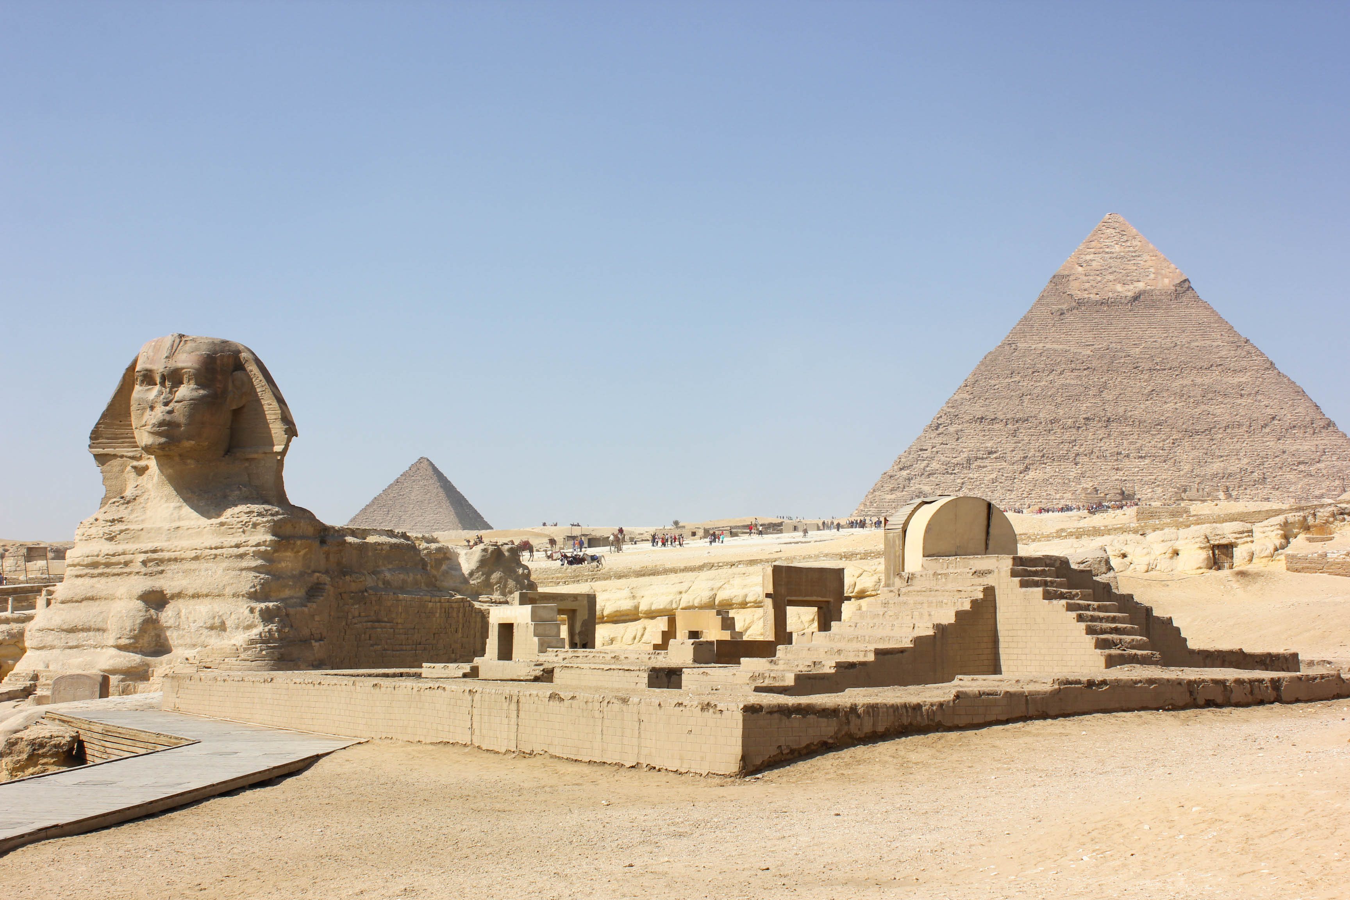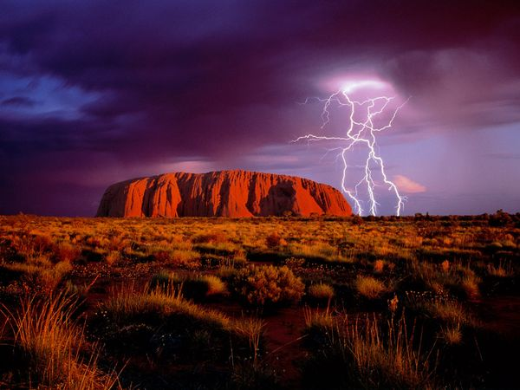

In P.E. we will be working on our agility by improving our reaction and response and will be performing routines that include static balance as part of our floor work. In Term 6 we will be looking at improving our stances and will continue to work on our agility through ball chasing.

Each morning, we will work on spelling rules and strategies and continue to learn the words stipulated in the National Curriculum spelling lists for Lower Key Stage 2.

‘The Egyptian Cinderella’ by Shirley Climo and ‘The Ancient Egypt Sleepover’ by Stephen Davies will be our Guided Reading texts this term. We will be asking questions to improve our understanding of the text and drawing inferences about the characters’ feelings, thoughts and motives from their actions.

During English lessons we will cover the understanding, formulation, planning, structuring and editing of written composition. We will be writing poems, narratives, and setting descriptions.

Our topics this term include:
-finishing our learning on length and perimeter
- Money – to be able to recognise coins, convert pence and pounds and find change
- Mass, Capacity and Volume-converting between different units of measurements as well as calculating with them
-Time - to recognise Roman numerals and be able to tell the time on analogue and digital clocks.
-properties of shape-including parallel and perpendicular lines, horizontal and vertical lines and angles and right angles.
-Statistics- making pictograms and bar charts and learning how to interpret these

We will continue consolidating other areas of the maths curriculum through our daily Maths meetings.

We will continue consolidating other areas of the maths curriculum through mathematical investigations throughout the term.

MATHEMATICS
PE
ENGLISH

00
RE

In R.E. the key questions that we will be exploring are, ‘What is the Qur’an and why do many Muslims try to learn it by heart?’ This unit will follow on from our learning about Islam earlier in the year, but will have a focus on the messages in the Qur’an. After half term, we will think about the question, ’Does it matter if a story is true or not?’ This will introduce the idea of truth and reality and allow children an opportunity to think philosophically.

MUSIC
PSCHE
FRENCH

We will be looking at the names of instruments and fruits and vegetables over the summer terms.

COMPUTING

This term we will be learning about branching databases. We will learn how to sort objects using yes/no questions, complete a branching database and create our own databases based on our own choices.

Our values this term are Courage and Forgiveness.
In SCARF we will continue with our Keeping Safe unit before moving on to our Rights and Respect.

As musicians we will be exploring the Disco music genre in our unit ‘Bringing us together’. In Term 6 we will be learning to sing and perform songs for the KS2 end of year performance

