Key Areas of Learning

As Historians, we will be learning about The Great Fire of London! Using primary sources and our knowledge of London, we will be able to say when the fire occurred and how it started/spread. We will look at how Britain in the 1600’s was different to the country we now live in and we will also understand how events like The Great Fire have shaped our views on construction methods and fire safety today.
As Designers, we will be learning how to build a structure inspired by the houses of the seventeenth century. We will learn how to attach materials and build structures to make them strong and stable. We will create our own dwellings from the Stuart period and put them together to recreate our own mini fire of London.

Fletcher Class -Year 2
Spring Term 1 2026
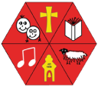

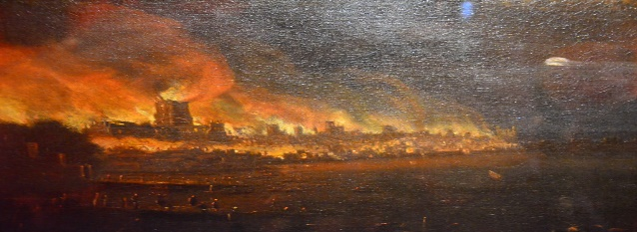

As Mathematicians, our focus areas for this term include
- Shape: We will investigate 2D and 3D shapes and begin to use the correct terminology. We will also look at symmetry.
- Money: Children will be looking at counting money (notes and coins), comparing amounts and start to use prior learning to calculate with money
- Multiplication & Division: To begin with, we will use arrays to understand equal groups.

As Scientists, we will be learning all about materials. We will be naming and identifying materials and learning about their properties. We will be thinking about the suitability of using different materials for different purposes. We will be carrying out simple tests to determine whether some materials are better for different purposes than others.

English lessons will focus on three core texts this term that link to the Great Fire of London. We will use this to help us write poetry, newspaper reports and a diary in role as Samuel Pepys as if we witnessed the fire ourselves!
Within each unit, we will learn grammar skills to help develop our writing, such as how to use write expanded noun phrases, use adjectives to describe the fire and how to use punctuation accurately, including exclamation marks.

As Physical learners we will be working on our Dynamic and Static Balancing skills.
Children will develop and apply their dynamic balance on a line and stance through focused skills improvement sessions and team activities.

PE
MATHEMATICS
ENGLISH
SCIENCE
SCIENCE

00
COMPUTING

As Digital Learners we will be learning all about how to use the internet to effectively search for relevant and useful information. We will focus on safety and narrowing down search criteria to make best use of this incredible resource.

As Musicians we will be listening with concentration to short pieces of music and beginning to explain why the music has a certain effect on us. We will be creating sound using percussion instruments that represent something from the real world like animals or weather patterns. We may even try and replicate the sound of the Great Fire using musical instruments!

In R.E. we will be learning about how Christians decide what is right and what is wrong.
We will look at the role of The Ten Commandments and the teachings of Jesus in helping Christians make the right choices in how to live their lives. We will also study the parable of The Good Samaritan and investigate how this shows Christians what God says is the right way to live. One of our key questions this term will be “What would Jesus do?”

As Social, Emotional learners, our SCARF unit this term will be learning about Keeping safe. We will be exploring how to keep safe around medicines as well as exploring different situations in which the children might feel safe or unsafe. We will be learning about how facial expressions and body language can show if someone is feeling safe or unsafe and we will be discussing who to talk to if they are feeling unsafe.

MUSIC
RE
PSHCE

