Who were the

As Historians we will be exploring the Jurassic Era and discovering as much as we can about the incredible giants that roamed the earth and what happened to them. As novice palaeontologists we will learn about the work of Mary Anning and her contributions to palaeontology and the discovery of these amazing creatures that roamed our world a very long time ago.
As Designers we will make our own dinosaurs and name them. We will also create a moving dinosaur in a Jurassic scene. We will use clay and become potters to create our Christmas decoration learning about a kiln and glazing our pottery. We will make a card in the same theme using different painting techniques.

Key Areas of Learning
Who were the Jurassic Giants?
Spencer Class Year 1
Autumn Term 2 2025-2026
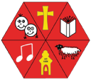

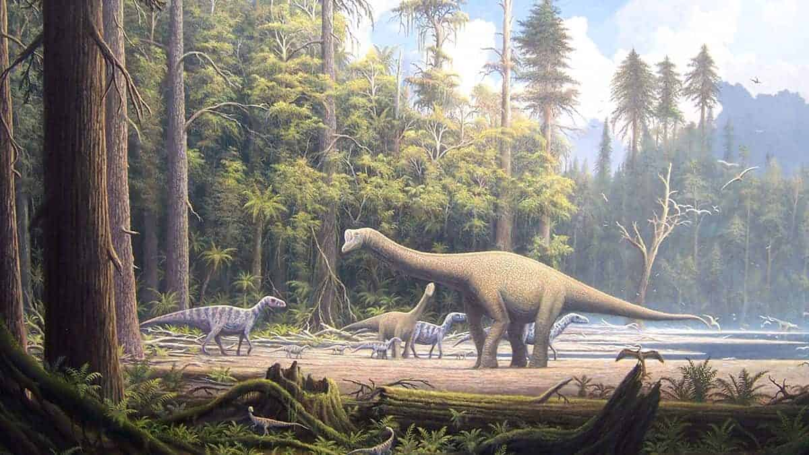

As Scientists, we will be looking at materials. We will be exploring the differences in materials and how we use them in everyday life.
We will be collecting, identifying, classifying, observing, and naming everyday materials.

In English we will write our own stories using ‘The Dinosaur and the Girl’ as our inspiration. We will look at ‘Dasher’ and the adventure he went on to discover the North Pole. We will write descriptions of what he saw when he travelled from Africa to the North Pole.
In addition to our English lessons, we will continue to have daily phonics through the Read, Write Inc programme. We will begin to read and spell some common exception words.
MATHEMATICS

Our focus areas for this term include Numbers to 20, addition and subtraction within 10, 2D and 3D shapes. We will embed all our previous learning through maths meetings and revision of mathematical concepts especially part, part, whole and number bonds.

ENGLISH

In P.E we will be focusing on how we travel and balance. We will continue to work on improving our ball skills.

PE
SCIENCE
SCIENCE

00
RE

In R.E. we will explore how people celebrate festivals in different religions. We will try to unpick the question: Should we celebrate harvest or Christmas?

This term we will be focusing on the value of RESPECT.

In PSHCE we will be looking at ‘Me and my Relationships’ and understanding who our special people are who can help us.

COMPUTING

We will be learning how to stay safe online and how to navigate Purple Mash learning to use our own work areas with their topics and tools. We will then move on to sorting, firstly away from the computer and then on the computer.
PSHCE
MUSIC

In music we will be exploring singing and performance as we rehearse for our Christmas Nativity!

FRENCH

In French this term, we will continue to learn everyday greetings. We will start to ask simple questions such as, ‘How are you?’ and learn how to reply.

