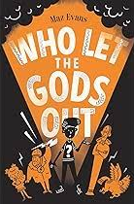
It’s all Greek to me
Garrett Class -Year 4
Autumn Term 2025 Term 2
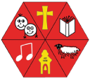
Key Areas of Learning

As Historians, we are exploring the way Ancient Greek society was made up, ruled and worshipped. We will also be studying famous events in Greek History, like the Battle of Thermopylae and the Siege of Troy. We will be using Greek myths and religious beliefs as part of our study of the everyday lives of Greeks and examining the legacy left, including language and alphabets, democracy and the Olympic Games.
As designers, we will be looking at food planning, preparation and evaluation, as well as examining the hygiene and safety methods need for proper food preparation. We are making use of the produce grown in our school garden to make pumpkin and squash soup (and baking bread with herbs) as part of our sustainability learning and land use. We will also be planning meals based on nutrition and ease of preparation and storage.

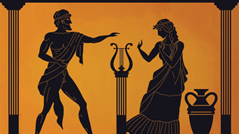

As Physical learners we will be focusing on developing our Coordination skills, our static and dynamic balances and our jumping and landing skills. We will also be developing our stamina for cross-country and building our team- playing skills in a range of games.

PE

In English we will be studying reading writing and grammar Each morning we will work on spelling rules and strategies and continue to learn the words stipulated in the National Curriculum spelling lists for Lower Key Stage 2. We will be reading the wonderful book, ‘Who let the Gods out?” by Maz Evans, (which will help with our History learning) and look at comprehensions to improve our skills. In writing we will be giving the children the opportunity to write independently as well as producing biographies letters and some short Christmas poems.

As Mathematicians, our focus areas for this term include multiplication and division, examination of factors and multiples and the application of this when calculating area. We will count in multiples (6,7,9,25 & 1000) and solve practical and reasoning problems in all Maths topics, including measurement of length and perimeter.
We will be consolidating our learning through Maths meetings and times table practice and games and activities.
SCIENCE
MATHEMATICS

As Scientists, we will be learning about the states of matter (solids, liquids and gases). We will be examining the ways particles react to create matter and how sometimes this can be changed reversibly and sometimes irreversibly. We will also be looking are the way we group materials and studying the way water and carbon acts in cycles (reversible and irreversible).

ENGLISH

COMPUTING

As Digital Learners the children will learn about the safe use of the internet and online safety applications, games and the dangers of and issues inherent in use of social media.

In French this term, we will be learning vocabulary for the classroom, as well as the use of full sentences that include the verb avoir (J’ai-I have)
We will also be continuing to practise our French greetings and pronunciation

As Musicians we will be learning how to play Glockenspiels and read simple tablature to play songs and melodies independently. We will also be practicing singing in the build up to Christmas with carols and Christmas songs.
MUSIC

As Social, Emotional learners, our SCARF unit is exploring healthy relationships, what is and isn’t ok and how to deal with feelings and pressure that come from relationships.

We will also take time to focus on each of the Astonishing learner values and what these
look like.
.

In R.E. we will explore the way that after Jesus’ life ended, the church began. We will be be looking at the instructions and actions of the Apostles and how the church has moved through the ages, from persecution and acceptance of the Romans, the Middle ages and the reformation, onto more modern and contemporary church settings.
RE
PSHCE
FRENCH

