Twinkle Twinkle Night Time World
Evans
Autumn Term 2
Topic Information

This term we will be exploring light and dark, nocturnal animals and their habitats, how are senses adapt to light and dark and we will look forward to Christmas and preparing for our first performance. Although we have a topic theme, many of the areas of learning are inspired by the children as such, some of the ideas and activities may look a little different as we adapt to the children’s interests.

We will be learning some number and counting songs and we learn some actions to help us to remember the words. We will learn to match and sort objects based on different criteria. We will also practice the days of the week, subitising to 5 and comparing amounts using the language :fewer, more and the same.

.
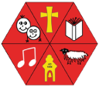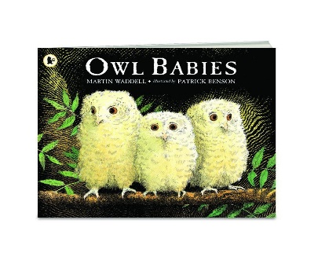
MATHEMATICS
Literacy

Each week we have a book of the week that will be read daily for children to really get to know, and to learn and understand new vocabulary. We will focus on new words like characters and setting. The story to life through props and puppets and acting out the story.
We will provide opportunities to orally rehearse and record a sentence using Class dojo. Some of our books this term include: Flashlight, Owl Babies and Can’t you sleep little Bear.

Expressive arts and Design

We will introduce a black out sensory tent where children explore light using torches and making shadows.
In art, we will explore Van Gogh and his painting Starry Starry Night trying to develop similar effects of our own and make a collaborative piece of own. We will introduce Drawing Club by Greg Bottrill which is a fun, play-based club based on a weekly story.

Phonics: We follow a programme called Letters and Sounds. This term we will focusing on consolidating aspect 1 environmental sounds and aspect 2 –- instrumental sounds for children who have attended the setting before.
We have introduced syllables in names and Fred talk (Oral Blending).
Listening, attention and Understanding- we will be looking at different aspects of night time- listening to stories. We will be able to answer simple questions about the story and identify features of the book, including the front cover and back cover.

Gross motor – we will be focusing on gaining control of our gross motor movements by joining in 5-minute runs, Joe Wicks workouts and Cosmic Kids’ yoga, as well as our weekly PE sessions.

Fine motor: The children will be given the opportunity daily to explore our fine motor area of playdough, finger gym and mark making. Fine motor activities are so important for children to develop the hand strength they need to learn how to write.

We use a programme called SCARF for our PSED development – this term we will be focusing on Me and My Friends –(this unit includes lots of talk about relationships with other peers, how to be a good friend and compromising.

We encourage all children in nursery to put on their own shoes and coats.

We will also continue to encourage children to wash their hands regularly.

Understanding the World

This term , we will be exploring night time. Why some animals are nocturnal, light and dark, using torches and different sources of light.

Communication & Language
Physical development
Personal, Social and Emotional

00

For RE this term, we will be learning about the Christmas story and how Christians celebrate .

Religious Education

Our value will still be very much a theme with children getting used to this new language and expectations. We will also be doing daily feelings check ins using Zones of Regulation.
SMSC & Values

