People That Help Us
Evans
Autumn Term
Topic Information

The first term we will spend lots of time getting to know the children what their likes and dislikes are and which areas of learning they enjoy. We will spend the first two weeks focusing on emotions and feelings as part of the story The Colour Monster. We will also read The Colour Monster which is based on identifying emotions and feelings. We will compare our feelings to the monsters. We will understand how to label our emotions and begin to show empathy in others. Although we have a topic theme, many of the areas of learning are inspired by the children as such, some of the ideas and activities may look a little different as we adapt to the children’s interests.

We will be learning some number and counting songs and we learn some actions to help us to remember the words. We will learn to match and sort objects based on different criteria. We will also ensure that the children are able to identify the colours as we will need this skill to help us to match and sort objects.

.
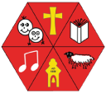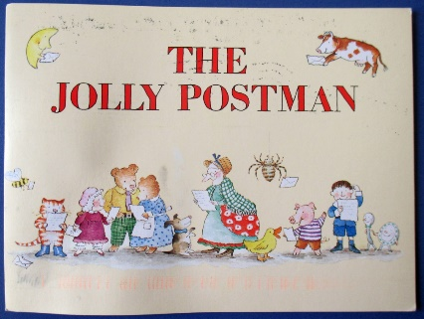
MATHEMATICS
Literacy

Each week we have a book of the week that will be read daily for children to really get to know, and to learn and understand new vocabulary. We will focus on new words like characters and setting. The story to life through props and puppets and acting out the story.
We will provide opportunities to orally rehearse and record a sentence. Some of our books this term include: Mog and the Vet, Doctorsaurus and The Jolly Postman.

This Photo by Unknown Author is licensed under CC BY-NC-ND

Phonics: We follow a programme called Letters and Sounds. This term we will focusing on consolidating aspect 1 environmental sounds and aspect 2 –- instrumental sounds for children who have attended the setting before. For new starters we will being with aspect 1. Which is about listening and tuning into the environmental sounds.

Listening, attention and Understanding- we will be looking at looking at the person who is talking and listening to stories. We will being to answer simple questions about the story and identify features of the book, including the front cover and back cover.

Gross motor – we will be focusing on gaining control of our gross motor movements by joining in 5-minute runs, Joe Wicks workouts and Cosmic Kids’ yoga, as well as our weekly PE sessions.

Fine motor: The children will be given the opportunity daily to explore our fine motor area of playdough, finger gym and mark making. Fine motor activities are so important for children to develop the hand strength they need to learn how to write.

We use a programme called SCARF for our PSED development – this term we will be focusing on Me and My Relationships –(this unit includes lots of talk about families and special people, as well as identifying what is special about them as individuals)

We encourage all children in nursery to put on their own shoes and coats.

We will also continue to encourage children to wash their hands regularly.

Expressive arts and Design

Our role play area will be a vets, a post office, and a Doctors. We will also be doing craft activities linked to ourselves, creating our own portraits and using different medias for mark making. We will introduce Drawing Club by Greg Bottrill which is a fun, play-based club based on a weekly story.

Understanding the World

This term we will be exploring People that help us. We will be looking at different roles in the community. These will include Postal workers, Doctors, Vets and the Fire Crew.

With Autumn fast approaching, we will also be thinking about the changing seasons. What vegetables are produced and what we can make with them.
Communication & Language
Physical development
Personal, Social and Emotional

00

We will be introducingthe school’s 5 values of Respect, Honesty, Love, Courage, and Forgiveness. We will also be doing daily feelings check ins using Zones of Regulation.

For RE this term, we will be learning about Special People in our lives as well as Jesus and Moses.

SMSC & Values
Religious Education

