
Aston and Cote CE Primary School – Knowledge Organiser 2025/2026
Subject: Maths | Year 2 | Term 1

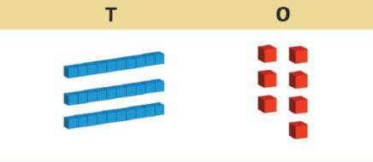
Place value is the number system that we use to describe the position and value of each digit within a number.
The number 12 has been put into place value columns below.
We can see that the number 12 has 1 ten and 2 ones.

Remember: 1 ten is equal to 10 ones.
Challenge: Find out the ages of people in your family and put them into place value columns.
If your mum is 37, you would lay it out like this:
Place Value

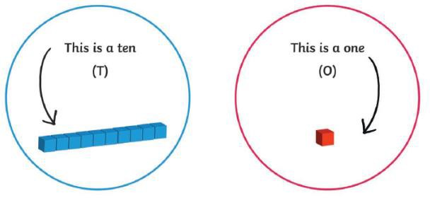
Tens | Ones
T | O
1 | 2

Tens | Ones
T | O
3 | 7

Shapes | x2, x5, x10
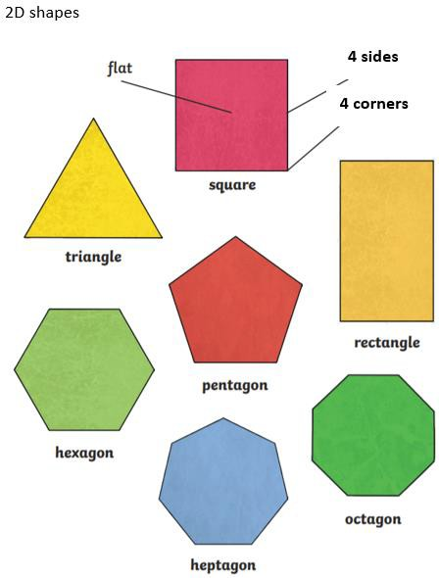 | 0 x 2 = 0 0 x 5 = 0 0 x 10 = 0  1 x 2 = 2 1 x 5 = 5 1 x 10 = 10  2 x 2 = 4 2 x 5 = 10 2 x 10 = 20  3 x 2 = 6 3 x 5 = 15 3 x 10 = 30  4 x 2 = 8 4 x 5 = 20 4 x 10 = 40  5 x 2 = 10 5 x 5 = 25 5 x 10 = 50  6 x 2 = 12 6 x 5 = 30 6 x 10 = 60  7 x 2 = 14 7 x 5 = 35 7 x 10 = 70  8 x 2 = 16 8 x 5 = 40 8 x 10 = 80  9 x 2 = 18 9 x 5 = 45 9 x 10 = 90  10 x 2 = 20 10 x 5 = 50 10 x 10 = 100  11 x 2 = 22 11 x 5 = 55 11 x 10 = 110  12 x 2 = 24 12 x 5 = 60 12 x 10 = 120

Number Bonds to 20
+ = 20 | 20 - =
For Example:  11 + 9 = 20 | 20 - 8 = 12

