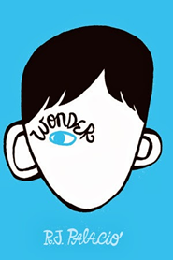
It’s all Greek to me
Garrett Class -Year 4
Autumn Term 2025 Term 1
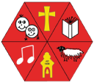
Key Areas of Learning

As Geographers, we will be learning about Europe; its human and physical features, cultures and climates (and how these affect settlement and land use). We will explore some of the cultural similarities and differences between European countries and how their locations affect things like diet and trade. We will also be growing our map reading and drawing skills.
As Artists, we will be exploring Ancient Greek pottery, including their use of pictures to tell stories. We will also be using practical skills to make our own vases using clay and decorating them in the Greek style. In addition, we will be exploring drawing people in proportion to help us with our progression in drawing.

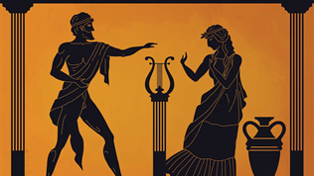

As Physical learners we will be focusing on developing our Coordination skills, our static and dynamic balances and our jumping and landing skills. We will also be developing our stamina for cross-country and building our team- playing skills in a range of games.

PE

As Mathematicians, our focus areas for this term include: place value, addition and subtraction, area and multiplication and division. We will count in multiples (6,7,9,25 & 1000) find 1000 more or less of a number, estimate and round and solve practical problems in all Maths topics, including measurement of length and perimeter and begin exploring conversions of metric units.
We will be consolidating our learning through Maths meetings and times table practice.
SCIENCE
MATHEMATICS

As Scientists, we will be learning about teeth. We will be able to identify different types of teeth in humans and their simple functions. Also, comparing the differences between human and animal teeth.
We will also be looking at the digestive system as a whole and how food is processed to give us energy, whilst also looking at healthy eating.

English will begin with spelling before moving on to reading comprehension and the planning, drafting and editing component of the lesson. Each morning we will work on spelling rules and strategies and continue to learn the words stipulated in the National Curriculum spelling lists for Lower Key Stage 2. We will be reading the wonderful book, ‘Wonder’ by R.J Palacio. We will be looking at diaries, descriptive writing, and narratives. Spelling and grammar will be woven throughout these units.

ENGLISH

COMPUTING

As Digital Learners the children will learn about coding and how to use block instructions using the format on Purple Mash.

RE
PSHCE
FRENCH
MUSIC

In French this term, we will be learning vocabulary for fruit and vegetables.
We will also be continuing to practise our French greetings and pronunciation

As Musicians we wil be learning to sing, play and improvise the song, ‘Mamma Mia!’. We will then learn about the language of music through playing the glockenspiel.

As Social, Emotional learners, our SCARF unit is exploring healthy relationships, what is and isn’t ok and how to deal with feelings and pressure that come from relationships.

We will also take time to focus on each of the Astonishing learner values and what these
look like.
.

In R.E. we will explore these questions;
Who do Christians believe Jesus is?
This will include the 2 natures of Jesus being a human and divine, and explore what this means to Christians.

