Represent 4-digit numbers | Rounding | Roman Numerals
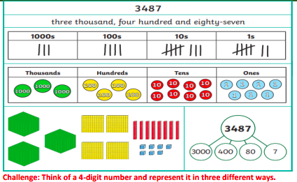 | 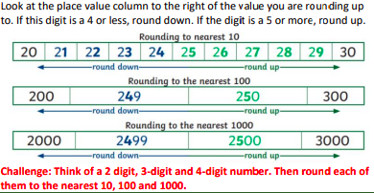 | 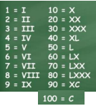
Compare and order | 1000 more or 1000 less | Vocabulary
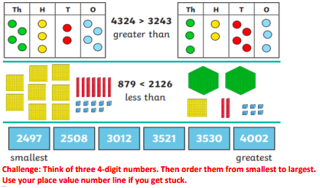 | 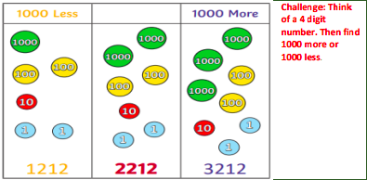 | Hundreds  Thousands  Tens  Ones  Place value  Greater than  Less than  Order  Round  Partition  Digit  Negative number  More  Less  Roman Numeral  Number line
 | Number line
 | 

