Key Areas of Learning

As Geographers, we will be learning about our capital city, London and how this compares to our village. We will be naming and locating the countries of the Uk and looking and some characteristics of each part of the UK. We will be looking at famous London landmarks and will be plotting these onto maps. We will be using a compass and positional language to follow routes on a map of London.
As Designers, we will be exploring a classic British recipe, Shepherd’s Pie! We will be learning all about food hygiene to make sure that we prepare our food safely and healthily. We will use our school garden to explore where our food comes from and will pick some and learn how to peel and chop it safely ready to cook. As a team, we will work together to follow a recipe to cook our pie and then taste it and offer our opinions on what we have made!

Fletcher Class -Year 2
Autumn Term 1 2025
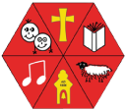

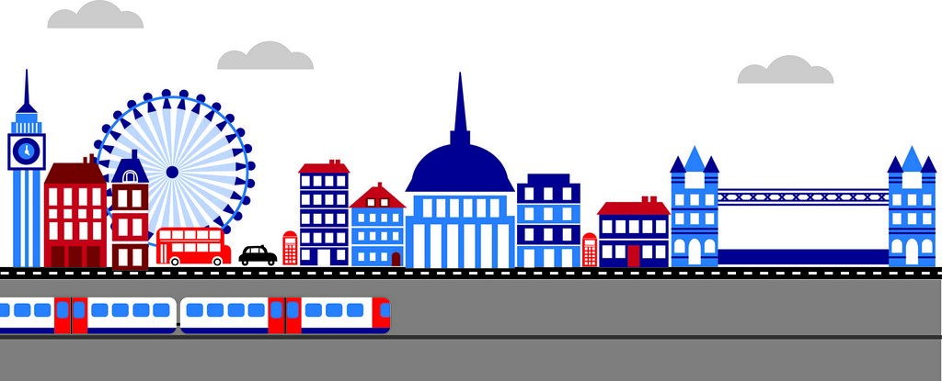

As Mathematicians, our focus areas for this term include: -
- Number and place value- working on recognising, ordering, writing and counting up to 100.
- Understanding the place value of numbers to 100 in a variety of ways (how many tens and ones the number is comprised of)
- We will be looking at methods for addition and subtraction, including using our number bonds to 10 and then 20, adding three numbers together, as well as adding and subtracting across a ten.

As Scientists, we will be learning about seasonal changes as we move into Autumn and start to think about the arrival of winter. We will be using our school grounds to spot signs of seasonal change as well as thinking about how animals prepare themselves for winter. We will explore changes in weather and will use our observation skills to watch and record the temperature and wind.

English lessons will focus on exploring books with links to London, such as The Naughty Bus, Katie Goes to London and We Completely Must go to London. We will be reading and exploring the books together and will use these as a stimulus to write our own texts. Over the course of this term, we will be retelling stories, changing and improving stories and writing in role as a character to create a diary. Within each unit, we will be learning grammatical skills such as writing in the past tense, using apostrophes to show possession, using adjectives and verbs in sentences and joining sentences using a range of words e.g and, or and but.

As Physical learners we will be focusing on building our key skills of balance and core strength using simple activities to train our bodies in these areas. Mr Hook will be developing the children’s football skills with a focus on teamwork and resilience.

PE
MATHEMATICS
ENGLISH
SCIENCE
SCIENCE

00
COMPUTING

As Digital Learners we will be learning how to code! Children learn to build simple algorithms to move a screen turtle along routes. They consider direction, distances and create commands.

As Musicians we will be celebrating and learning about South African music. All the learning is focused around one song: “Hands, Feet, Heart”. We will use a variety of games to teach children about the pulse, rhythm and pitch, while learning to sing and play instruments. As well as all this, we will also be listening to and appraising different styles of South African music

In R.E. we are looking at Christianity and how Christians find out what God is like. We will draw from Old and New Testament stories so that the children may observe what the difference is. We will look at the life of Jesus and how that it reflects the character of God. There will be time to explore parables and their role in helping Christians understand God’s nature. Finally, we will look at the Holy Trinity as well as how Christians choose to live out God’s nature by doing charitable works.

As Social, Emotional learners, our SCARF unit this term will be “Me and my relationships”. During our learning time we will understand how to acknowledge and manage our own feelings, talk about their impact on our wellbeing and that of others. We will also touch on healthy friendships and what makes a good friend. Discussions on bullying and how to deal with it will form part of our learning as well as deciphering the difference between being teased and being bullied.

MUSIC
RE
PSHCE

