Art and Design Intent: At Aston and Cote CE Primary we believe that high-quality Art lessons will inspire children to think innovatively and develop creative procedural understanding. Our Art curriculum provides children with opportunities to develop their skills using a range of media and materials. Children will be introduced to a range of works and develop knowledge of the styles and vocabulary used by famous artists. In Art, children are expected to be reflective and evaluate their work, thinking about how they can make changes and keep improving. This should be meaningful and continuous throughout the process, with evidence of age-related verbal and written refection. Children are encouraged to take risks and experiment and then reflect on why some ideas and techniques are successful or not for a particular project. Children are given a range of experiences to explore, develop new skills and grow their talents.
National Curriculum Objectives
Key stage 1  By the end of each key stage, pupils are expected to know, apply and understand the matters, skills and processes specified in the relevant programme of study |  |  |  | Key Stage 2  Key Stage 2 By the end of each key stage, pupils are expected to know, apply and understand the matters, skills and processes specified in the relevant programme of study. In Key Stage 2 pupils should be taught to develop their techniques, including their control and their use of materials, with creativity, experimentation and an increasing awareness of different kinds of art, craft and design.
Pupils should be taught:  ▪ To use a range of materials creatively to design and make products  ▪ To use drawing, painting and sculpture to develop and share their ideas, experiences and imagination ▪ To develop a wide range of art and design techniques in using colour, pattern, texture, line, shape, form and space  ▪ About the work of a range of artists, crafts makers and designers, describing the differences and similarities between different practices and disciplines, and making links to their own work |  |  |  | Pupils should be taught:  ▪ To create sketchbooks to record their observations and use them to review and revisit ideas  ▪ To improve their mastery of art and design techniques, including drawing, painting and sculpture with a range of materials (for example pencil, charcoal, paint, clay)  ▪ About great artists, architects and designers in history
Drawing
Year 1 |  |  | Year 2 | Year 3 | Year 4 | Year 5 | Year 6
A Year 1 Artist will: |  |  | A Year 2 Artist will: | A Year 3 Artist will: | A Year 4 Artist will: | A Year 5 Artist will: | A Year 6 Artist will:
▪ Explore a range of drawing tools to make marks  ▪ Begin to control the types of marks made with a range of media.  ▪ Draw on different surfaces  ▪ Explore different textures  ▪ Draw from imagination  ▪ Explore drawing from observation  ▪ Investigate textures by describing, naming, rubbing and copying  ▪ Produce a range of patterns and texture |  |  | ▪ Experiment with tools and surfaces  ▪ Draw experiences and feelings  ▪ Sketch to make records  ▪ Begin to control marks made with different media  ▪ Investigate tone by drawing light/dark lines using pencil  ▪ Investigate textures and produce an expanding range of patterns | ▪ Experiment with various pencils  ▪ Use a sketchbook to document and develop ideas  ▪ Draw from observation and imagination  Experiment with mark making using alternative tools  ▪ Create initial sketches for painting  ▪ Begin to draw with accuracy  ▪ Discuss shadows, light and dark  ▪ Have an awareness of how pattern can be used to create texture | ▪ Consider scale and proportion  ▪ Create accurate observational drawings ▪ Work on a ▪ variety of scales ▪ Produce drawings using IT  ▪ Identify and draw the effect of light  ▪ Draw for a sustained period of time  ▪ Develop techniques to create intricate patterns – range of media | ▪ Work in a sustained and independent way to create an accurate, detailed drawing. Developing key elements of their work (line, tone, pattern, texture)  ▪ Draw from different viewpoints considering horizon lines.  ▪ Begin to consider perspective  ▪ Use different techniques for purpose eg. different styles of shading  ▪ Work from a variety of sources including observation and photographs to develop own work | ▪ Select appropriate media and techniques to achieve a specific outcome  ▪ Develop their own style  ▪ Draw for a sustained period of time over a number of sessions  ▪ Use tone in drawings to achieve depth ▪ Develop drawing with perspective and focal points  ▪ Adapt drawings according to evaluations and discuss further developments
Sticky Knowledge/ Retrieval

Mark making- such as: Cross hatching,  Continuous line drawing, patterns, using different media- biro |  |  | Mark making- such as: Cross hatching,  Continuous line drawing, patterns, using different media- biro | Mark making- such as: Cross hatching,  Continuous line drawing, patterns, using different media- biro  Tone  Pencil grading  3- dimension  Perspective | Mark making- such as: Cross hatching,  Continuous line drawing, patterns, using different media- biro  Tone  Pencil grading  3- dimension  Perspective | Mark making- such as: Cross hatching,  Continuous line drawing, patterns, using different media- biro  Tone  Pencil grading  3- dimension  Perspective  Mixed Media  Observational drawing  Scale  Proportion | Mark making- such as: Cross hatching,  Continuous line drawing, patterns, using different media- biro  Tone  Pencil grading  3- dimension  Perspective  Mixed Media  Observational drawing  Scale  Proportion Composition  Horizon
Vocabulary | pencil, grip, press, hold, shape, lines | Texture, tone, shape. Form, media, surfaces, explore, sketchbook,  Hatching, scribbling, stippling, blending, rubbing, copying | Control, media,  Texture, tone, shape. Form, media, surfaces, explore, sketchbook, light and dark, tonal ladder  Hatching, scribbling, stippling, blending, rubbing, copying | Intricate patterns, grades of pencil, source material, drawing implements,  Control, media,  Texture, tone, shape. Form, media, surfaces, explore, sketchbook, light and dark, tonal ladder  Hatching, scribbling, stippling, blending, rubbing, copying | Intricate patterns, grades of pencil, source material, drawing implements,  Control, media,  Texture, tone, shape. Form, media, surfaces, explore, sketchbook, light and dark, tonal ladder  Hatching, scribbling, stippling, blending, rubbing, copying  Third dimension  Source material | Intricate patterns, grades of pencil, source material, drawing implements,  Control, media,  Texture, tone, shape. Form, media, surfaces, explore, sketchbook, light and dark, tonal ladder  Hatching, scribbling, stippling, blending, rubbing, copying,  tonal contrast, mixed media, single perspective, single focal point, horizon,  Scale, proportion  View finders | Intricate patterns, grades of pencil, source material, drawing implements,  Control, media,  Texture, tone, shape. Form, media, surfaces, explore, sketchbook, light and dark, tonal ladder  Hatching, scribbling, stippling, blending, rubbing, copying  Tonal contrast, mixed media, single perspective, single focal point, horizon,  Scale, proportion  View finders
Supporting resources
 | 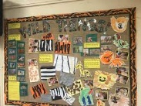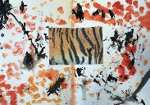Grade 2: TEXTURE (Elements of Art) (youtube.com)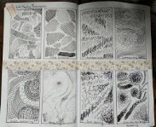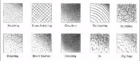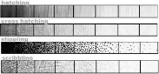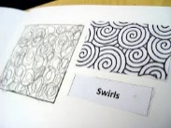 | https://www.google.co.uk/url?sa=t&rct=j&q=&esrc=s&source=video&cd=&cad=rja&uact=8&ved=2ahUKEwjXiOn7q4eEAxV6WEEAHUYhAukQtwJ6BAgHEAI&url=https%3A%2F%2Fwww.youtube.com%2Fwatch%3Fv%3DbsSveswnQik&usg=AOvVaw2FPxuWutlbrmHb1gDfSBR9&opi=89978449 | 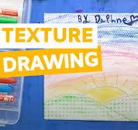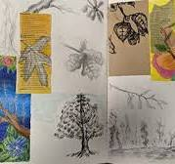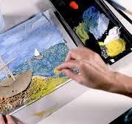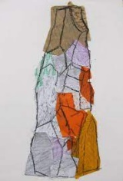 | 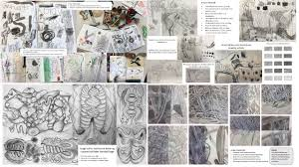https://www.google.co.uk/imgres?imgurl=https%3A%2F%2Fimg.cdn.schooljotter2.com%2Fsampled%2F18485664%2F1280%2F720%2Fnocrop%2F%2F&tbnid=nRAziprRMjYHfM&vet=12ahUKEwjM9LDhjfaDAxUH0AIHHfGMCH0QMygqegUIARCnAQ..i&imgrefurl=https%3A%2F%2Fgomersalfirst.org.uk%2Four-classes%2Fart-mrs-barrett&docid=FeC2Q90lS7E0NM&w=1280&h=720&q=mark%20making%20progression&hl=en&safe=active&ved=2ahUKEwjM9LDhjfaDAxUH0AIHHfGMCH0QMygqegUIARCnAQ  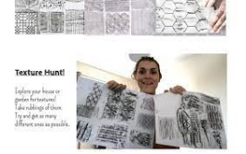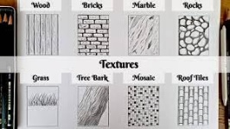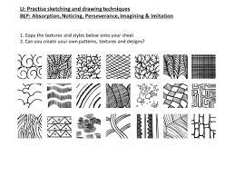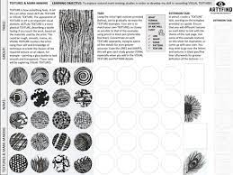 | 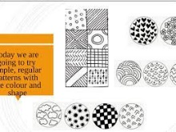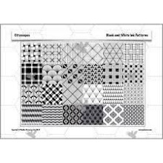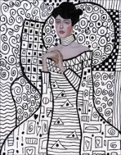  https://www.google.co.uk/imgres?imgurl=https%3A%2F%2Fi.ytimg.com%2Fvi%2F1KEjtcsZ4TI%2Fsddefault.jpg&tbnid=wRY_nD52utl7JM&vet=12ahUKEwjImdzd8vWDAxUTmycCHUxSCbkQMygregUIARCyAQ..i&imgrefurl=https%3A%2F%2Fm.youtube.com%2Fwatch%3Fv%3D1KEjtcsZ4TI&docid=_E96JrXfpsiUfM&w=640&h=480&q=create%20intricate%20patterns%20ks2&ved=2ahUKEwjImdzd8vWDAxUTmycCHUxSCbkQMygregUIARCyAQ | 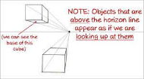https://www.google.co.uk/search?q=Develop+further+simple+perspective+in+using+a+single+focal+point+and+horizon+kids&source=lmns&tbm=vid&bih=716&biw=1474&hl=en&sa=X&ved=2ahUKEwjentj49fWDAxXJY6QEHcpBA44Q0pQJKAJ6BAgBEAY#  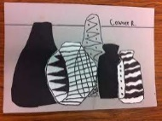  https://youtu.be/RixNaqZPUkM
Substantive Concept/ Strand- Painting

Skills: Year 1 |  |  | Year 2 | Year 3 | Year 4 | Year 5 | Year 6
Begin to explore and experiment with the primary colours  ▪ Mix primary colours to create secondary colours  ▪ Describe collections of colours  ▪ Discuss and use warm and cold colours  ▪ Describe favourite colours and why colours may be used for different purposes  ▪ Explore a range of paint, brush sizes and tools |  |  | Begin to describe a range of colours  ▪ Mix a range of secondary colours  ▪ Talk about why they have selected colours for their artwork  ▪ Begin use a range of paint | Lighten a colour by adding white  ▪ Darken / Lighten colours without using black / white (e.g. dilute with water)  ▪ Explore a variety of media to create colour (paint, crayon, coloured pencil, textiles, ink, pastels etc) ▪ Demonstrate increasing control of the types of marks made to create certain effects using paint | Begin to alter paint colour using white, grey and black ▪ Observe colour and suggest why it has been used ▪ Select colour to reflect mood ▪ Explore different brush strokes and consider why / when they might be used ▪ Begin to discuss how they are influenced by the work of other artists | Mix colours with confidence, building on previous knowledge  ▪ Select colour for purpose, explaining choices ▪ Discuss how colour can be used to express ideas, feelings and mood. ▪ Confidently control the types of marks made and experiment with different effects and textures | Select colour to express feelings ▪ Work in a sustained and independent way, developing own style  ▪ Purposefully control the types of marks, brushstrokes used to create desired effec  t ▪ Use colours and brushstrokes to create atmosphere and light effects
Vocabulary | paint  mixing  brush  brush stroke colour  bright  dark | Primary  Secondary  Lightning  Darkening  Predicting  Colour wheel  Landscape  portrait | Primary  Secondary  Layering  Mixing  Colour wheel  Colour spectrums  Wet in wet  Lino prints  Landscape  portrait | Textural effects  Block in  Shades  Tones  Lino prints  Wet in wet  Layering  Colour spectrums  Tertiary colours  Landscape  portrait | Textural effects  Block in  Shades  Tones  Lino prints  Wet in wet  Layering  Colour spectrums  Tertiary colours  Landscape  Portrait  Landscape scene | Textural effects  Block in  Shades  Tones  Lino prints  Wet in wet  Layering  Colour spectrums  Tertiary colours  Landscape  Portrait  Landscape scene  Timeline  Art movements | . Textural effects  Block in  Shades  Tones  Lino prints  Wet in wet  Layering  Colour spectrums  Tertiary colours  Landscape  Portrait  Landscape scene  Timeline  Art movements
Supporting resources |  | https://www.google.co.uk/url?sa=t&rct=j&q=&esrc=s&source=video&cd=&cad=rja&uact=8&ved=2ahUKEwiL6a_oroeEAxVWW0EAHUhyBbQQtwJ6BAgLEAI&url=https%3A%2F%2Fwww.youtube.com%2Fwatch%3Fv%3DkJP6MLlSYgI&usg=AOvVaw1WkOGVE88zLAN7_AhsAApB&opi=89978449  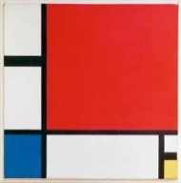 | https://www.google.co.uk/url?sa=t&rct=j&q=&esrc=s&source=video&cd=&cad=rja&uact=8&ved=2ahUKEwiL6a_oroeEAxVWW0EAHUhyBbQQtwJ6BAgPEAI&url=https%3A%2F%2Fwww.youtube.com%2Fwatch%3Fv%3DHizPR6EV1VQ&usg=AOvVaw3Uj40M72Her9i_jTklvF4e&opi=89978449  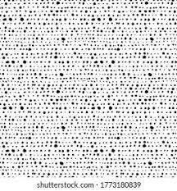  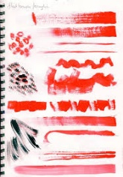  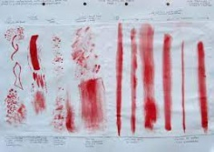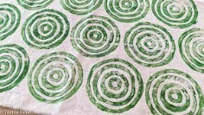 | 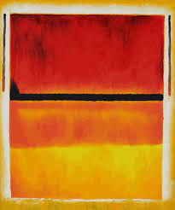 | 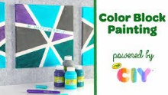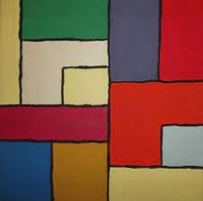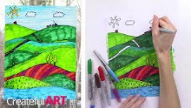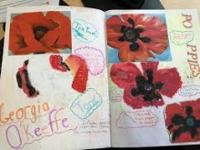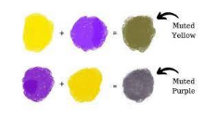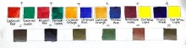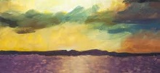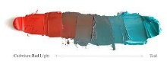 | 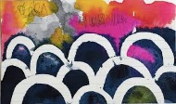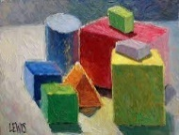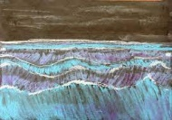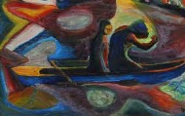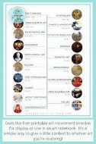  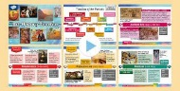 | 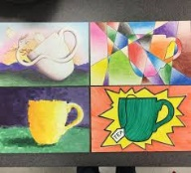
Substantive Concept/ Strand- 3D Sculpture
Skills: Year 1 |  |  | Year 2 | Year 3 | Year 4 | Year 5 | Year 6
Enjoy handling, feeling and manipulating a range of materials  ▪ Construct using a range of media  ▪ Cut shapes using scissors and other modelling tools in a safe way  ▪ Build a construction using a variety of objects  ▪ Discuss the different types of buildings in their locality |  |  | Show an awareness that natural and human made materials can be used to create sculpture ▪ Create models from imagination and direct observation  ▪ Join materials together and apply decorative techniques ▪ Discuss the work of other sculptors and relate these to their own ideas and designs | Plan, shape, mould and make constructions from different materials ▪ Show an awareness of how texture, form and shape can be transferred from 2D to 3D  ▪ Demonstrate awareness in environmental sculpture | Discuss the work of other sculptors and architects and how these have influenced their own work / designs  ▪ Make slip to join and secure pieces of clay together  ▪ Produce more intricate surface patterns using a range of processes  ▪ Adapt work when necessary and explain why. | Develop an understanding of different ways of finishing work (e.g. glaze, paint, varnish) ▪ Understand that a range of media can be selected (due to their properties) for different purposes ▪ Independently recognise problems and adapt work when necessary – taking inspiration from other sculptors | Recognise sculptural forms in the environment and use these as inspiration for their own work  ▪ Demonstrate experience in relief and freestanding work using a range of media  ▪ Independently select sculpture as a method of producing work, if this fits the criteria of the task
Sticky Knowledge/ Retrieval
Vocabulary | build make fix scissors | Manipulate  Malleable  Modroc  Papier mache  Carve  imprint | Manipulate  Malleable  Modroc  Papier mache  Carve  imprint  3-d  imagination | Manipulate  Malleable  Modroc  Papier mache  Carve  imprint  3-d  imagination  Join  Cross hatch  Pinch  Slab  coil | Manipulate  Malleable  Modroc  Papier mache  Carve  imprint  3-d  imagination  Join  Cross hatch  Pinch  Slab  Coil  Marquette  armature | Manipulate  Malleable  Modroc  Papier mache  Carve  imprint  3-d  imagination  Join  Cross hatch  Pinch  Slab  coil  Marquette  armature  Glaze  Paint  Polish  Aztec  Moore | Manipulate  Malleable  Modroc  Papier mache  Carve  imprint  3-d  imagination  Join  Cross hatch  Pinch  Slab  coil  Marquette  armature  Glaze  Paint  Polish  Aztec  Moore
Substantive Concept/ Strand- Printing

Skills: Year 1 |  |  | Year 2 | Year 3 | Year 4 | Year 5 | Year 6
Take rubbings from textured surfaces: e.g leaf, coin, tree bark  ▪ Print pictures with a range of materials e.g. sponge, reels  ▪ Begin to explore impressed printing e.g. with Styrofoam  ▪ Begin to identify different forms of printing e.g books, newspapers, fabric, wallpaper |  |  | Explore repeated printing using a range of simple methods  ▪ Explore mono printing  ▪ Identify a wider range of printed forms in everyday life and consider how the processes have changed over time | Design and create a repeated relief print considering background paper  ▪ Use sketchbooks to explore and develop prints making changes where needed  ▪ Understand the difference between repeat printing and mono printing | Explore the process of mono printing  ▪ Demonstrate an awareness of printing with multiple colours  ▪ Demonstrate an awareness of printing onto fabric and consider the difference to printing onto paper | Gain experience in overlaying colours  ▪ Start to overlay prints with other media ▪ Continue to experience in combining prints to produce an end piece  ▪ Explore, experiment, plan and collect source material for future work | Use Thermofax screens to explore screen printing  ▪ Combine different printing techniques within the same piece of artwork  ▪ Use print as a starting point to embroidery
Sticky Knowledge/ Retrieval
Skill
Vocabulary
Substantive Concept/ Strand- Digital Media

Skills: Year 1 |  |  | Year 2 | Year 3 | Year 4 | Year 5 | Year 6
Begin to explore digital media to create an image  ▪ Record information using digital cameras  ▪ Explore digital tools (e.g. brushes, shape and fill tools, eraser) |  |  | Use a graphics package or app to explore digital image creation ▪ Have the opportunity to manipulate an image using various digital tools ▪ Use a digital camera to take a specific image portrait/landscape | Use a graphics package or app to create images using different tools and effects with increased precision  ▪ To have experience of using an iPad to extend knowledge of photography | Experiment with colours and textures by making an appropriate choice of special effects and simple filters to manipulate and create images for a particular purpose ▪ Begin to use digital media to record and evaluate a creative learning journey | Confidently use a graphics package or app to create and manipulate images using a wider range of digital tools ▪ Understand that a digital image can be made up of different layers ▪ Create layered images from original ideas | Use digital media as a means of extending work from initial ideas ▪ Use digital media in order to self evaluate the creative learning journey ▪ Present personal ideas and choices using a range of digital media
Substantive Concept/ Strand- Collage
Year 1 |  |  | Year 2 | Year 3 | Year 4 | Year 5 | Year 6
Begin to use scissors and tearing to create a range of shapes ▪ Explores different methods of fixing one material to another  ▪ Create an image from a variety of cut or torn media  ▪ Arrange and glue materials to different backgrounds |  |  | Develops a range of cutting, tearing and fixing techniques to create a specific picture  ▪ Use scissors in a controlled way to cut with accuracy  ▪ Fold, crumple, tear and overlap papers to create an image  ▪ Has experience of different adhesives | Use collage as a means of collecting ideas and information to build a visual brainstorm ▪ Collect and select textured papers to form a collaged image | Develops experience in embellishing, using a range of joining techniques ▪ Experiment with a range of collage techniques such as tearing, overlapping and layering to create collaged images | To create a photomontage using given photographs from a range of sources  ▪ Add collage to a painted, printed or drawn background to enhance work | Use collage as a means of extending work from initial ideas ▪ Independently select a range of media to produce a collaged image
Cultural Capital |  | Year 1 | Year 2 | Year 3 | Year 4 | Year 5 | Year 6
 |  | Art gallery tour/  Workshop with visiting artist  Art Week  Art club | Art gallery tour /  Workshop with visiting artist  Art Week  Art club | Art gallery tour  Workshop with visiting artist  Art Week  Art club | Art gallery tour  Workshop with visiting artist  Art Week  Art club | Art gallery tour  Workshop with visiting artist  Art Week  Art club | Art gallery tour  Workshop with visiting artist  Art Week  Art club

