Aston & Cote Primary School – Knowledge Organiser |  |  |  |  |  |  |  |  |  | 
Maths |  |  |  |  | Year 3 |  |  | Term 2
Key times tables |  |  |  | Written method: Addition |  | Written method: Subtraction | Multiplication |  | Division
 | 0 x 8 = | 0 |  | Addition with no exchanges.  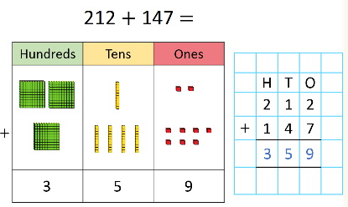  Have a go at:  452 + 326 132 + 662  237 + 542 731 + 153  Addition with exchanges.  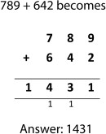  Have a go at:  528 + 491 655 + 265  378 + 377 852 + 259 |  | 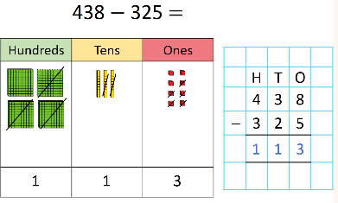  Subtraction with no exchanges.  Have a go at:  452 - 321 732 - 612  687 - 564 739 - 123  Subtraction with exchanges.  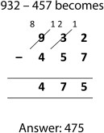  Have a go at:  452 - 326 732 - 661  537 - 349 831 - 753 | Using arrays to multiply  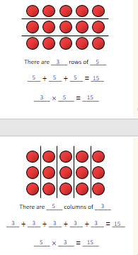  Make arrays for: 6 x 4 4 x 6  3 x 8 8 x 3  5 x 7 7 x 5  6 x 2 2 x 6 |  | 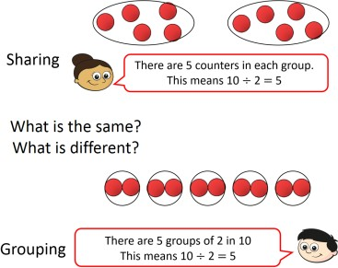  Have a go at grouping these:  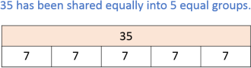  Use a bar model to share these:
 | 1 x 8 = | 8
 | 2 x 8 = | 16
 | 3 x 8 = | 24
 | 4 x 8 = | 32
 | 5 x 8 = | 40
 | 6 x 8 = | 48
 | 7 x 8 = | 56
 | 8 x 8 = | 64
 | 9 x 8 = | 72
 | 10 x 8 = | 80
 | 11 x 8 = | 88
 | 12 x 8 = | 96
 | 0 x 4 = | 0
 | 1 x 4 = | 4
 | 2 x 4 = | 8
 | 3 x 4 = | 12
 | 4 x 4 = | 16
 | 5 x 4 = | 20
 | 6 x 4 = | 24
 | 7 x 4 = | 28
 | 8 x 4 = | 32
 | 9 x 4 = | 36
 | 10 x 4 = | 40
 | 11 x 4 = | 44
 | 12 x 4 = | 48

