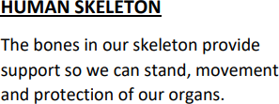
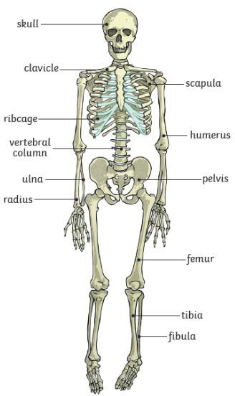
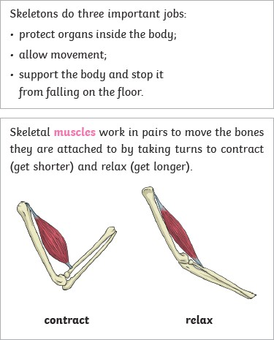
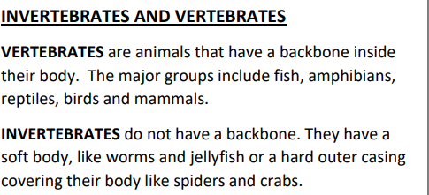
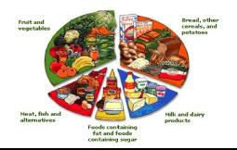
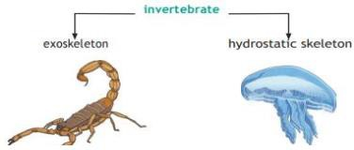
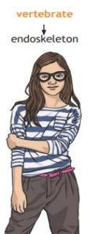
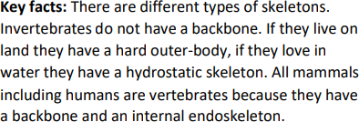
Aston & Cote Primary School – Knowledge Organiser
Science – Animals (including humans)
Year 3
Term 2
BALANCED DIET - Unlike plants, humans do not make their own energy so they need to eat to get energy. In order to be healthy we need to eat a balanced diet with more of some things and less of others.
PROTEIN – required for growth and repair of our bodies. Found in meats, poultry, fish, dairy products, eggs and beans.
CARBOHYDRATES – provide energy for the body. Found in grains, cereals, potatoes, bread, pasta and in some fruits and vegetables.
FATS – provide energy and help with building our bodies. Found in dairy products, red meats and some poultry and fish.
FIBRE – Help you digest your food. Found in cereals, fruit and bread.
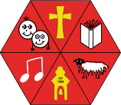

Key Vocabulary
Energy – the property that gives us strength of body or mind to do things or work
Nutrition – the process of providing or obtaining the food necessary for health and growth
Skeleton – a framework of bones supporting the body
Muscle – a soft tissue in the body that contracts and relaxes to cause movement of the skeleton
Healthy – in good physical condition
Consumers – living things that eat other living things to get energy
Vitamins – substances found in foods that keep you healthy
Diet – the foods that a person, animal or community habitually eat Invertebrate – an animal which does not have a back bone/spine Vertebrate – an animal which has a back bone/spine.


