WHAT IS A FOSSIL?
When an animal or plant dies, it usually decays quickly or can be eaten. However, sometimes an animal’s body sinks into thick mud where there is oxygen so the remains don’t decay or aren’t disturbed. The remains rest here for thousands/millions of years with more mud and pressure on them. Minerals in the mud turn the remains to stone.
Aston & Cote Primary School – Knowledge Organiser |  |  |  |  |  | 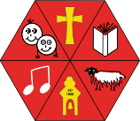
Science |  | Year 3 |  |  | Term 1
Rocks and Fossils
Key Vocabulary |  |  |  | TYPES OF ROCKS  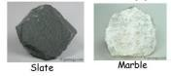  Igneous rocks - are very hard, dark and heavy. They are formed when molten magma from a volcano cools down. They tend to have  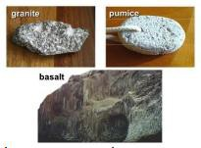  interlocking grains giving the rock a crystalline appearance.  EXAMPLES: granite, basalt, obsidian.  Metamorphic rocks - are rocks which have been changed over time by pressure or heat. Fossils can be found in metamorphic rocks if plants and animals have been trapped in the rocks. They are hard but can be damaged by acids. EXAMPLES: slate,  marble.  Sedimentary rocks – are formed by sediment  (which includes minerals, small pieces of plants and other organic matter) that is deposited over time. The sediment is compressed over a long period of time before it becomes solid layers of rock.  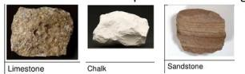  EXAMPLES: sandstone, limestone, flint, chalk
rock | A naturally occurring solid material composed of one or more minerals.
mineral | Solid chemical substances that occur naturally
fossil | The remains or impressions of a prehistoric plant or animal embedded in rock
igneous | Lava or magma that has turned from liquid to solid (forming a rock)
metamorphic | An igneous or sedimentary rock that has been changed by extreme heat or pressure
sedimentary | A rock formed from the build-up of sediment at the bottom of rivers or oceans
sediment | Dead animals, plants or pieces of rock that settle to the bottom of a liquid.
magma | Liquid rock inside a volcano
lava | Liquid rock which flows out of a volcano (ranges from 700 to 1200 degrees centigrade)
lava |  |  |  | WHAT IS SOIL?  Soil is made from pieces of rock, minerals, decaying plants and water. When rock is broken down into small grains, soil is formed. There are layers of soil: above the soil is leaf litter and recently decaying plants.  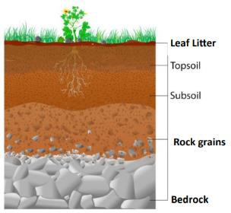  As the soil becomes deeper, the rock grains become larger until bedrock is reached.
tectonic plates | Pieces of land that connect together on the Earth's outer shell.


