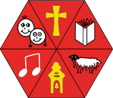
Aston & Cote - Year 3 Knowledge Organiser – Maths Place Value
Place value - The value of where a digit is in the number e.g. In 352, the 5 is in the "tens" place, so its place value is 10.
Partitioning – Splitting a number into smaller units. Digit – an individual numeral forming part of a number. Hundreds – 357 there are 3 hundreds in this number. Tens – 357 there are 5 tens in this number.
Ones – 357 there are 7 ones in this number
Greater than > – When a number has a higher value than the number it is being compared to e.g. 63
- 26
Less than < – When a number has a lower value than the number it is being compared to e.g. 17 < 50
Equal – Both sides are the same, they are balanced e.g. 72 = 72 or 12 +8 = 20
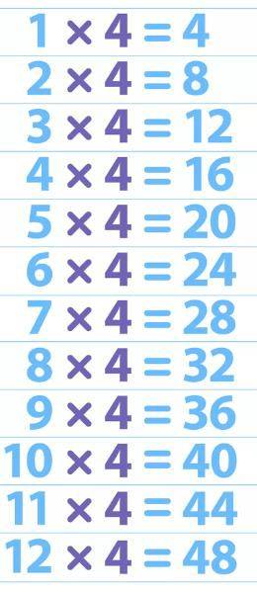
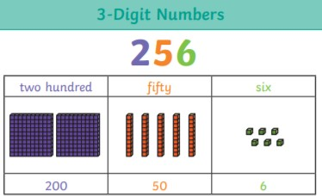
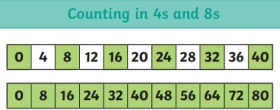
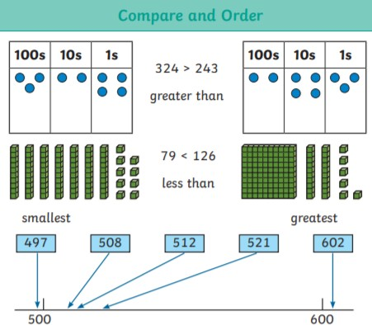
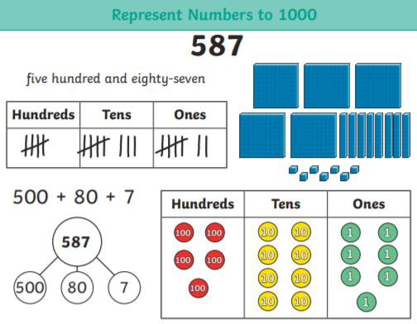
Hundreds | Tens | Ones
3 | 5 | 7



