Aston & Cote Primary School – Knowledge Organiser |  |  |  |  |  |  | 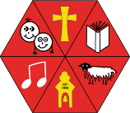
Science |  |  | Year 3 |  |  | Term 6
 | Key Vocabulary | Forces and Magnets
 | Force | A push or pull on an object which can cause it to move, change speed, direction or shape. Measured in Newtons (N). |  |  | Forces make this move. Whenever an object starts to move or moves faster, it is a force making this happen. Forces can also make things stop moving or slow down.  But what is a force?  - Forces are pushes and pulls.  - These pushes or pulls will always change the motion of an object. They will either make it start to move or speed up, slow it down or even make it stop.  What happens when you change the surface?  For example:  Cyclist sometime travel over different surfaces such as grass, gravel, sand or road. These surfaces all exert a force on the bicycle. This force is called friction.  Friction acts in the opposite direction to the movement of the object.  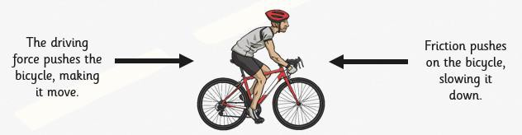  Different surfaces create different amounts of friction. The amount of friction created by an object moving over a surface depends on the  roughness of the surface and the object, and the force between them.
 | Magnet | A material or object that produces a magnetic field. It attracts or repels magnetic objects, including iron.
 | Contact Force | A force that requires physical contact to occur. E.g kicking a ball.
 | Attract | To pull towards. Opposite of repel.
 | Repel | To push away. Opposite of attract.
 | Propel | The act of driving or pushing forward.
 | Friction | The resistance of motion when one object rubs against another. Friction causes objects to slow down and the energy becomes heat.
 | Weight | The force due to gravity on objects. This force pulls on all objects near the earth. Measured in Newtons (N).
 | Mass | The amount of matter contained in an object. Measured in units such as g, kg.
 | Gravity | The area around a large object when a weight can be felt. The sun’s gravity keeps the planets orbiting around it.
 | Air Resistance | The frictional force of air against a moving object. The faster an object moves, the greater the air resistance.
 | Water Resistance | The frictional force of water against a moving object. The faster an  object moves, the greater the water resistance. |  |  | Magnets do not push or pull. The ends of a magnet are called poles. One end is called the north pole and the other end is  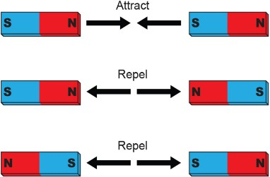  called the south pole. If you align two magnets so the south pole of one faces the north pole of the other, the magnets will move towards each other. This is when they attract. If you line the magnets up so that two of the same poles face each other, the magnets will move away from each other. This is when they repel.
 | Acceleration | Increase in the rate of speed of something.
 | Balanced Force | Two forces of equal size acting in opposite directions on an object so that it will stay still or continue to move in the same way
 | Unbalanced Force | Two forces of unequal size acting in opposite directions causing an object to move, change speed, direction or shape.

