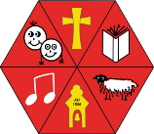
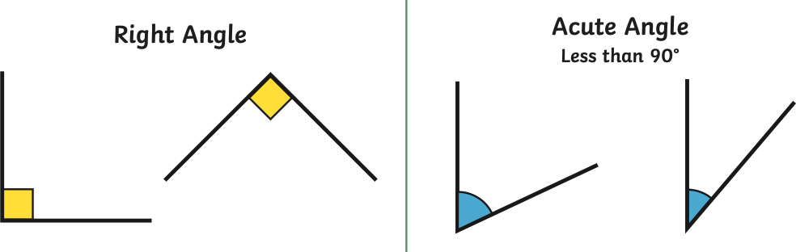
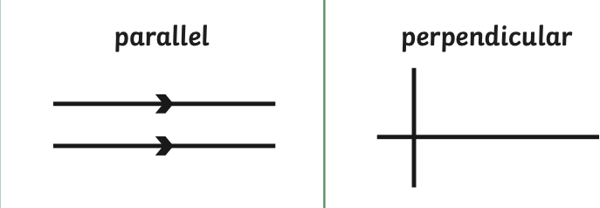
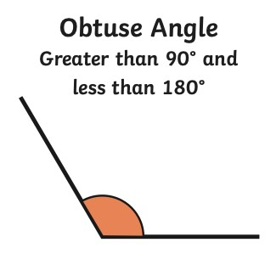
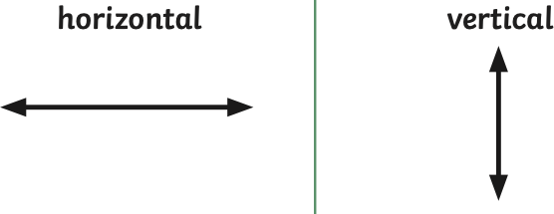
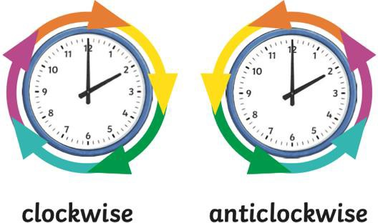
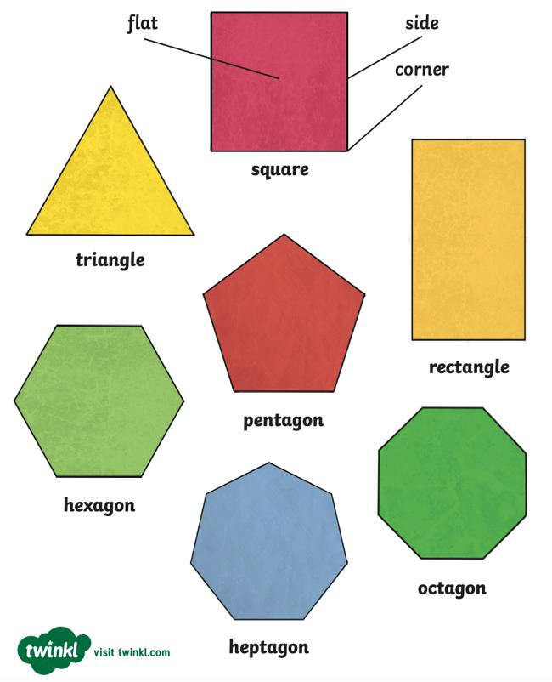
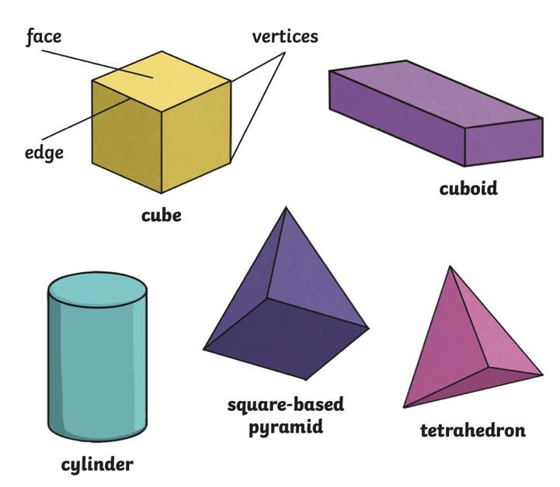
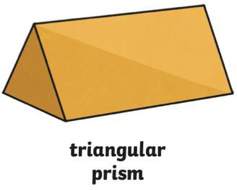
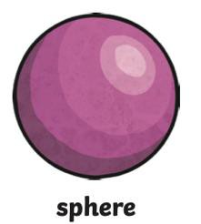
An angle is created when two lines meet at a point.
Could you draw some examples of angles and label them as acute, right angle or obtuse?
We describe 3-D shapes using faces, edges and vertices.
Could you draw and label the faces, vertices, and edges of these 3D shapes?
Parallel lines are always the same distance apart and will never meet.
Perpendicular lines cross over and meet at a right angle.
Can you find some examples of parallel and perpendicular lines?
We describe 2-D shapes using sides and corners.
These shapes may also have acute, obtuse or right angles.
Could you label the acute, obtuse and right angles in different shapes?
Shape
Aston & Cote Primary School – Knowledge Organiser
Subject: Maths | Topic: Shape | Year 3 | Term 6

Key Vocabulary - Shape
Parallel | Lines that are always the same distance apart and  will never meet.
Perpendicular | Lines that cross over and meet at a right angle.
Angle | A measure of a turn, which can be seen where  lines cross.
Right-Angle | An angle of exactly 90 degrees.
Horizontal | Lines that go from side to side (think of a horizon).
Vertical | Lines that go up and down.
Acute | Angles that are less than 90 degrees (smaller than  a right angle)
Obtuse | Angles that are more than 90 degrees (bigger than  a right angle).

