As Geographers we will be exploring the seven continents and five oceans. We will locate where China and the United Kingdom are and discover some of their physical and human features. We will begin to use accurate geographical vocabulary to describe these features. We will compare Beijing and London looking at similarities and differences between both. As part of being a global citizen we will look at the global goals to support a healthy, sustainable world for all who live on our planet.
As Designers we will build a bridge and check the strength of its structure. As part of design and technology we will prepare and cook a Chinese stir fry as part of our Wow Day!

Key Areas of Learning
Wok this Way!
Spencer Class Year 1
Summer Term 1 2026
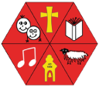

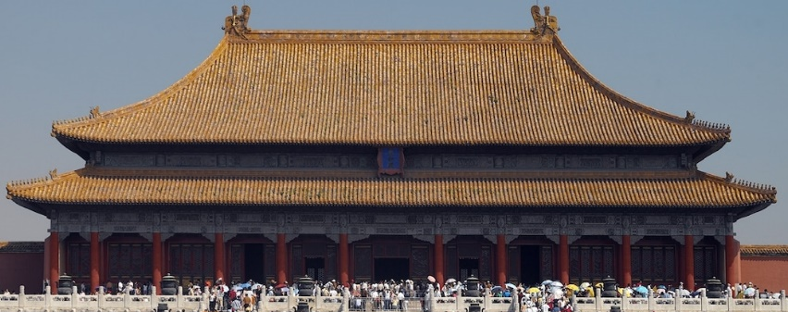

This term we are reading books linked to Chinese myths and traditions; Chopsticks and The Runaway Wok are our story books. They will be our inspiration for letters, writing stories and improving our writing skills. We will continue to make sure we always use capital letters, finger spaces and full stops.
Read, Write Inc will take place daily to improve our phonics helping us with our reading, spelling, and writing skills.

.
We will carry on reading and spelling the first 100 words. Grammar will be woven throughout these units.
.

As Scientists, we will be exploring plants. We will be looking at how they grow, identifying and naming different types of plants and understanding how seasons affect their growth. We will begin to understand the factors needed for healthy plant growth by growing our own sunflowers.

MATHEMATICS

In Maths we will be working with numbers to 50, adding, subtracting, and solving number problems. We will look at length and height, and weight and volume. We will continue to learn our 2, 5 and 10 timetables. Maths Meetings will focus on all maths previously taught to embed our maths knowledge.

ENGLISH

In our Tuesday lessons Maypole Dancing will be taught. Our Friday P.E lessons we will be focusing on coordination, agility, and athletics.

PE
SCIENCE
SCIENCE

00
We will continue to study Judaism in R.E. this term and ask the question ‘Why is Shabbat important to Jewish people? We will look at what Shabbat is and how Jewish people celebrate it.

acceptable

RE

COMPUTING

In computing we will carry on creating basic programmes with Maze Mazes on Purple Mash. We will move on to learn how to make simple animated stories using 2Create a Story. The iPads will be used to help us with our geography and science learning.

PSHCE

This term we will be focusing on the value of HONESTY.
In PSHCE we will be looking at growing and changing, examining our wonderful bodies, and learning how to keep them safe.

MUSIC

We will be following the lessons where the children learn how to identify high and low notes and compose a simple tune to represent a superhero.
FRENCH

We will continue to do our morning registration in French to keep up our greeting and number skills.

