As Geographers we will focus on our precious planet, looking at where live in this incredible world. We will explore the countries that make up the UK, their capital cities and the seas that surround them. We will look at how we can help to protect our oceans to save them from pollution and how as a global citizen we all have a part in helping to look after our planet for future generations.
As Designers will design and make our own ‘Save the Planet’ t shirts to wear at our WOW event. We will also make our own unique pebble to represent who we are! We will create calm jars to help us regulate our feelings and emotions.

Key Areas of Learning
Precious Planet
Spencer Class Year 1
Spring Term 2 2026
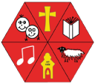

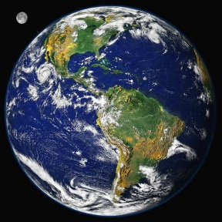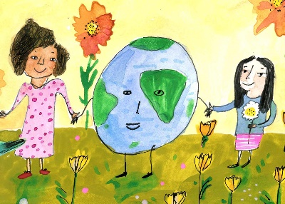

In P.E we will focus on co-ordination, counterbalance, and games, using our skills to improve our balance, focus and listening.

As Scientists, we will be exploring animals. We will classify animals into different groups by how they look and what they eat.
We will adopt an endangered animal as part of our global advocacy project helping to protect our precious planet.

In English we will write letters to Mother Earth to say we are sorry for harming our precious planet and suggest ways we can protect it. ‘Here we Are’ by Oliver Jeffers with be our focus book enlightening us with ideas. We will also read ‘Only One You’ and ‘You be You’ by Linda Krantz to celebrate our uniqueness. In addition to our English lessons, we will continue to have daily phonics through the Read, Write Inc programme.
We will begin to read and spell some common exception words.
MATHEMATICS

In Maths we will concentrate on numbers from 0 to 50, understanding their value, using them on number lines, in addition and subtraction, number bonds, fact families and solving picture and word problems. We will continue to learn our 2-, 5- and 10-times tables.
Our Maths Meetings will focus on all maths previously learnt to constantly embed our maths knowledge.

ENGLISH
PE
SCIENCE
SCIENCE

00

We will study Judaism in R.E. this term asking the question ‘What do different Jewish people believe about God?’ This unit explores Jewish beliefs about God, looking at Abraham and the Shema.

RE

COMPUTING

Using Purple Mash, we will become ‘Maze Explorers’ learning how to write simple instructions to move around a maze on a tablet. We will constantly use our interactive whiteboard to help with all our learning.

PSHCE

This term we will be focusing on the value of HONESTY.

In PSHCE we will be looking at Keeping Safe and Rights and Respect.

MUSIC

As musicians we will make links between music, sounds and environments and use percussion, vocal and body sounds to represent the seaside.
FRENCH

We will do our morning registration in French to keep up our greeting and number skills, telling our names and answering how we are feeling.

