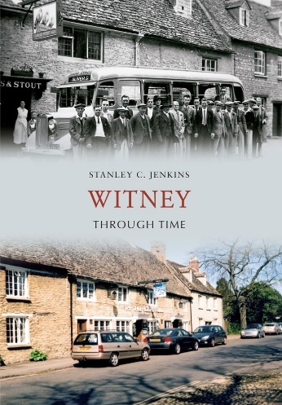
Home sweet Witney
Garrett Class -Year 4
Summer Term 2026 Term 5
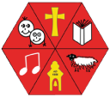
Key Areas of Learning

As Historians, we will be exploring our local area, with special interest in the Town of Witney, and its history since the Norman Conquest. We will be examining its industrial heritage, including the wool and blanket trade and the corn exchange. We will explore the Medieval church and the areas around the green and look at the life and works of prominent locals like William Wilkinson.
As designers, we will be using textiles to make stationary storage for both 2 and 3 dimensional items. The skills we will be learning will range from measuring, cutting, using templates and several stitching and joining techniques. We will also look at aesthetics and materials as part of our design brief and evaluation criteria.

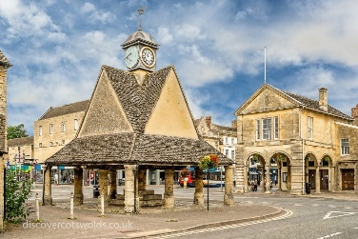

As Physical learners we will be focusing on developing our Coordination skills, our static and dynamic balances and our jumping and landing skills. In addition, we will be practicing local dances for our May Day celebrations. We will also be continuing our school orienteering activities.

PE
SCIENCE

As Scientists, we will be learning more about living things and their habitats. This will include grouping and categorising animals based on characteristics, exploring how animals are suited to certain environments and how damage to these environments has put animals at risk. We will also be examining local fauna as part of our exploration of our local area and its history, for example the gravel lakes around Witney.

SCIENCE

In English we will be studying reading writing and grammar Each morning we will work on spelling rules and strategies and continue to learn the words stipulated in the National Curriculum spelling lists for Lower Key Stage 2. We will be reading a non-fiction book about the History of Witney and looking at writing in a similar style. We will also be producing balanced arguments and continuing to deepen our understanding of description and imagery in narrative writing as well as writing independently to keep using our own “voices” in writing.

As Mathematicians, we will continue reinforcing our numerical fluency using the four operations and also examining problem solving and reasoning based on shape, area and units of measurement for weight and length and time,
We also will be continuing to practice our times tables in preparation for the national year 4 assessment. Further to this we will be continuing to practice the fundamentals of maths; place value and looking at negative numbers.
MATHEMATICS
ENGLISH
ENGLISH

COMPUTING

As Digital Learners we will be exploring making electronic music on computer (using Baby Beats) as well as recording and using sample sounds and editing our final compositions. The unit will focus on different sounds and instruments that can be utilised on composing a piece of music or a song.

FRENCH

In French this term, we will be continuing our work on simple conversations, based on questions and answers. This will include continuation of our work on the weather and how we present ourselves. We will also be recapping work on numbers and dates in French.

As Musicians we will be beginning to explore the idea of composition, using digital resources like Baby Beats (from Purple Mash) and Garage band on the iPads. This will focus on rhythm, intonation and melody and will allow the pupils to explore not only making music with different sound types, but also recording and editing it.
RE
MUSIC

We will take time to focus on each of the Astonishing learner values and what these
look like in real life. In addition, we will be looking at the SCARF module on Rights and Respect, focusing on what our and other people’s rights are, how we can make a difference and what are the expectations of us in a society.
.

In R.E. we will continue to explore the Hindu faith by examining the question, “What role does worship play in Hindu daily life?” To this end we will look at the terms and practices for Puja and Aarti as well as how Murtis are used to focus Hindu worship. We will also look at the comparisons between Hindu practices and those of other faiths.
PSHCE

