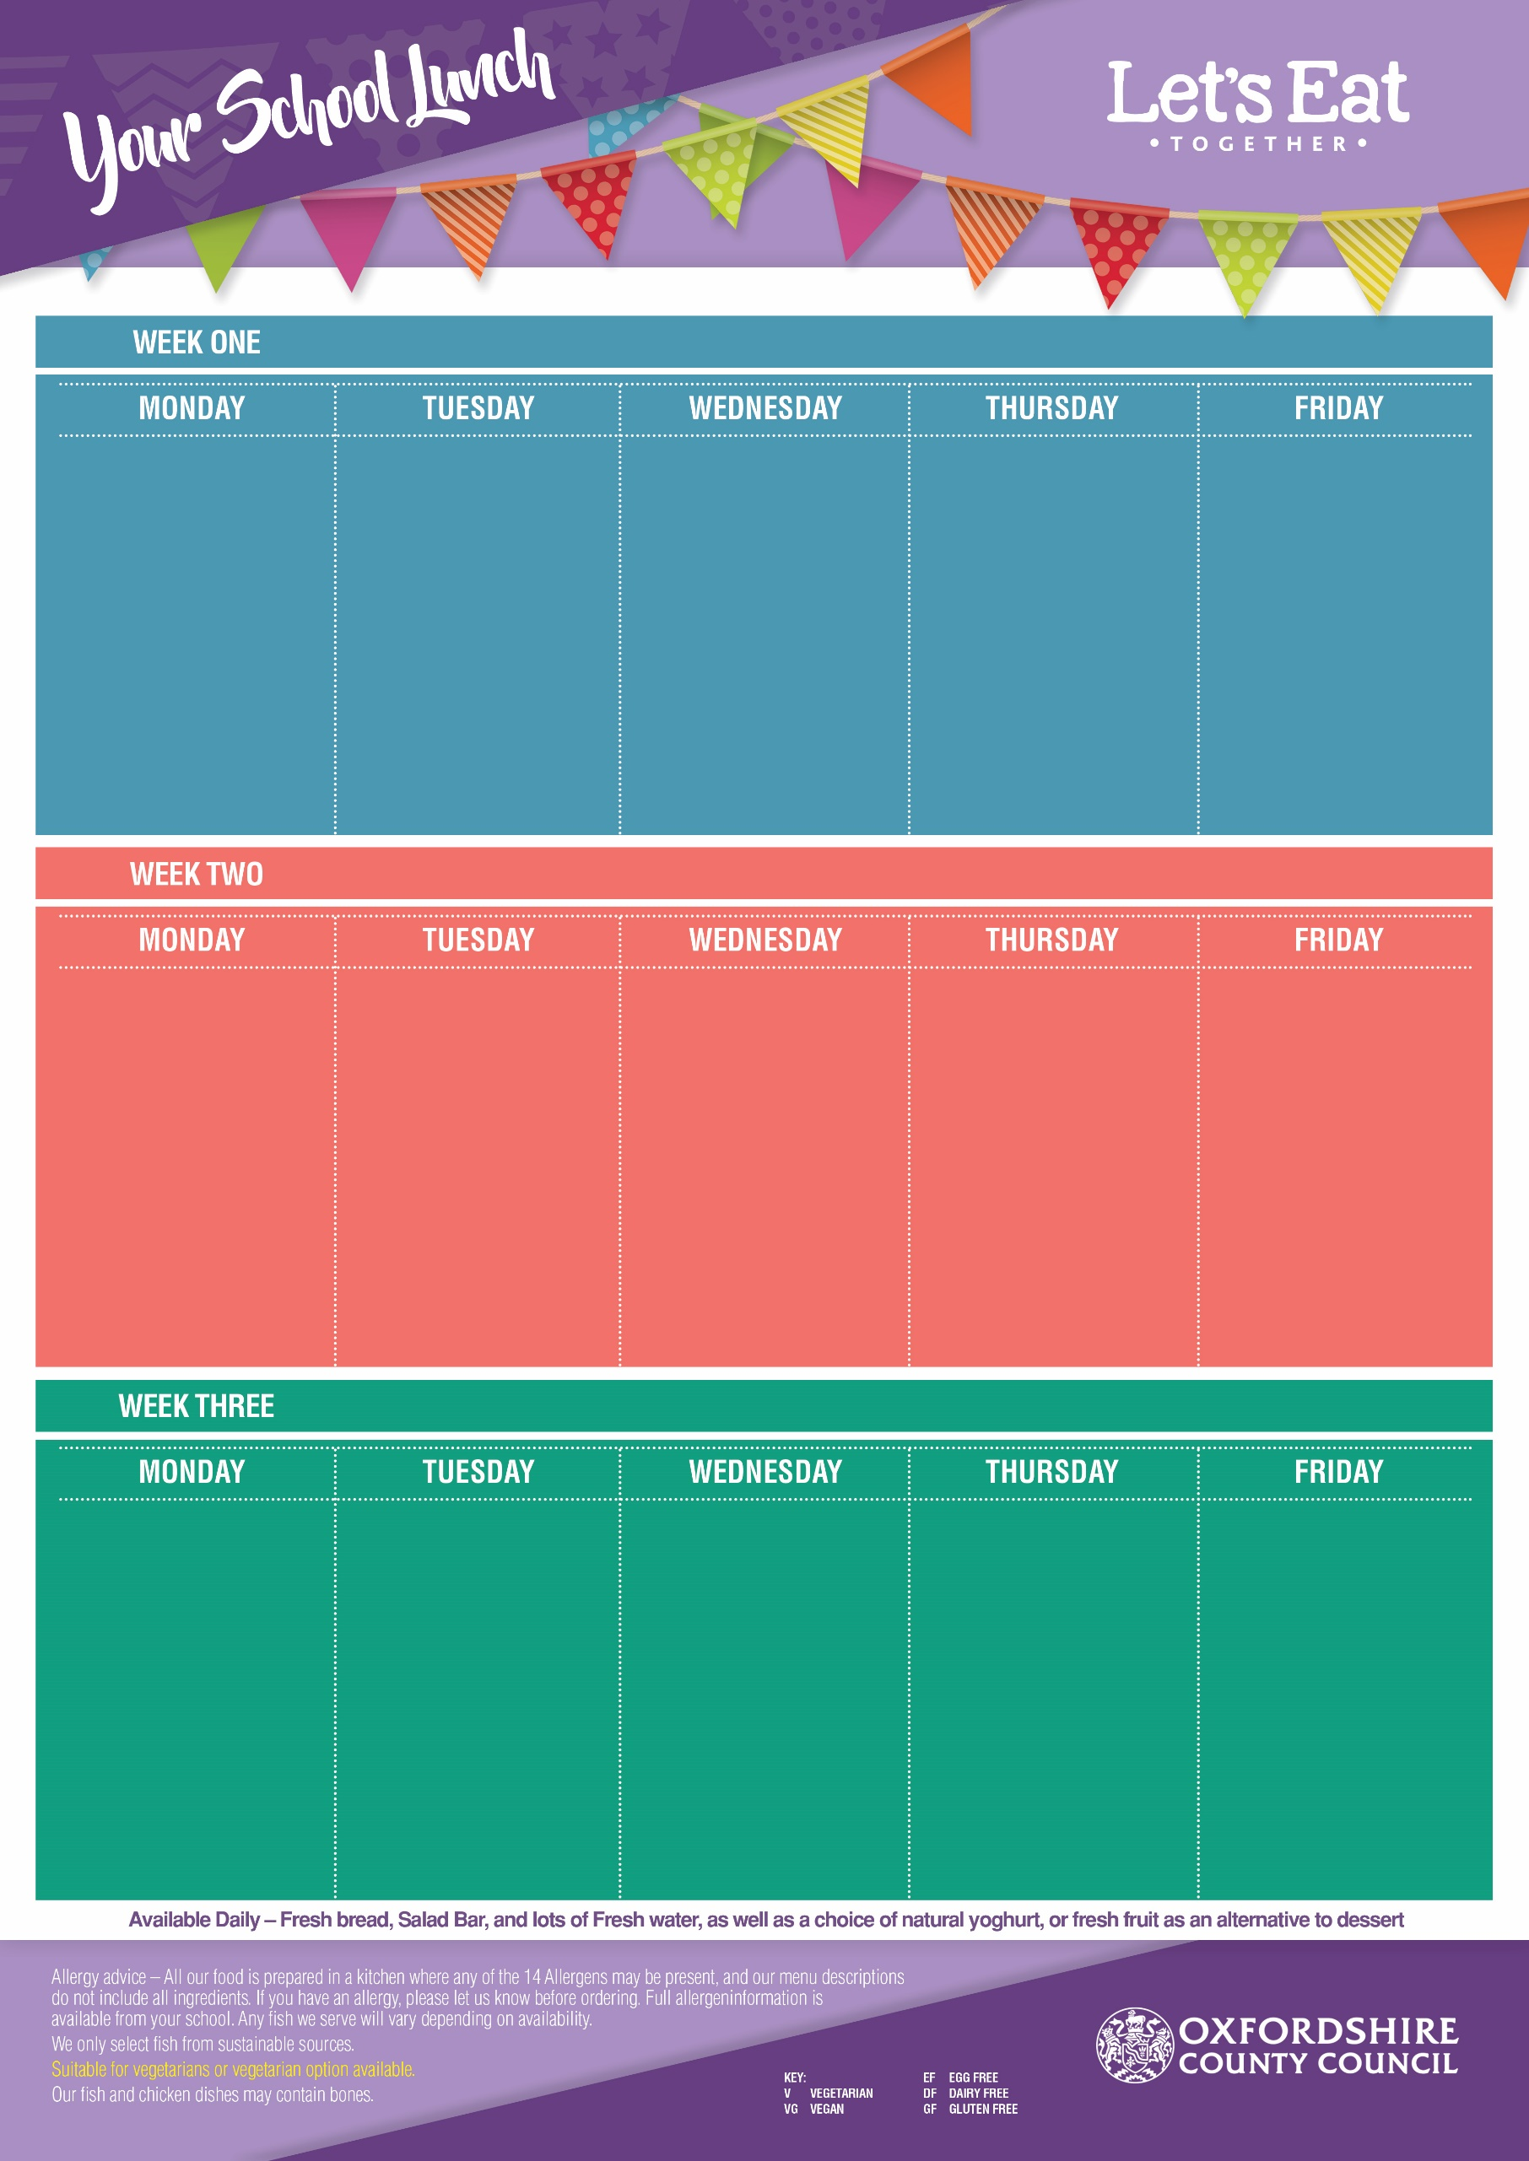
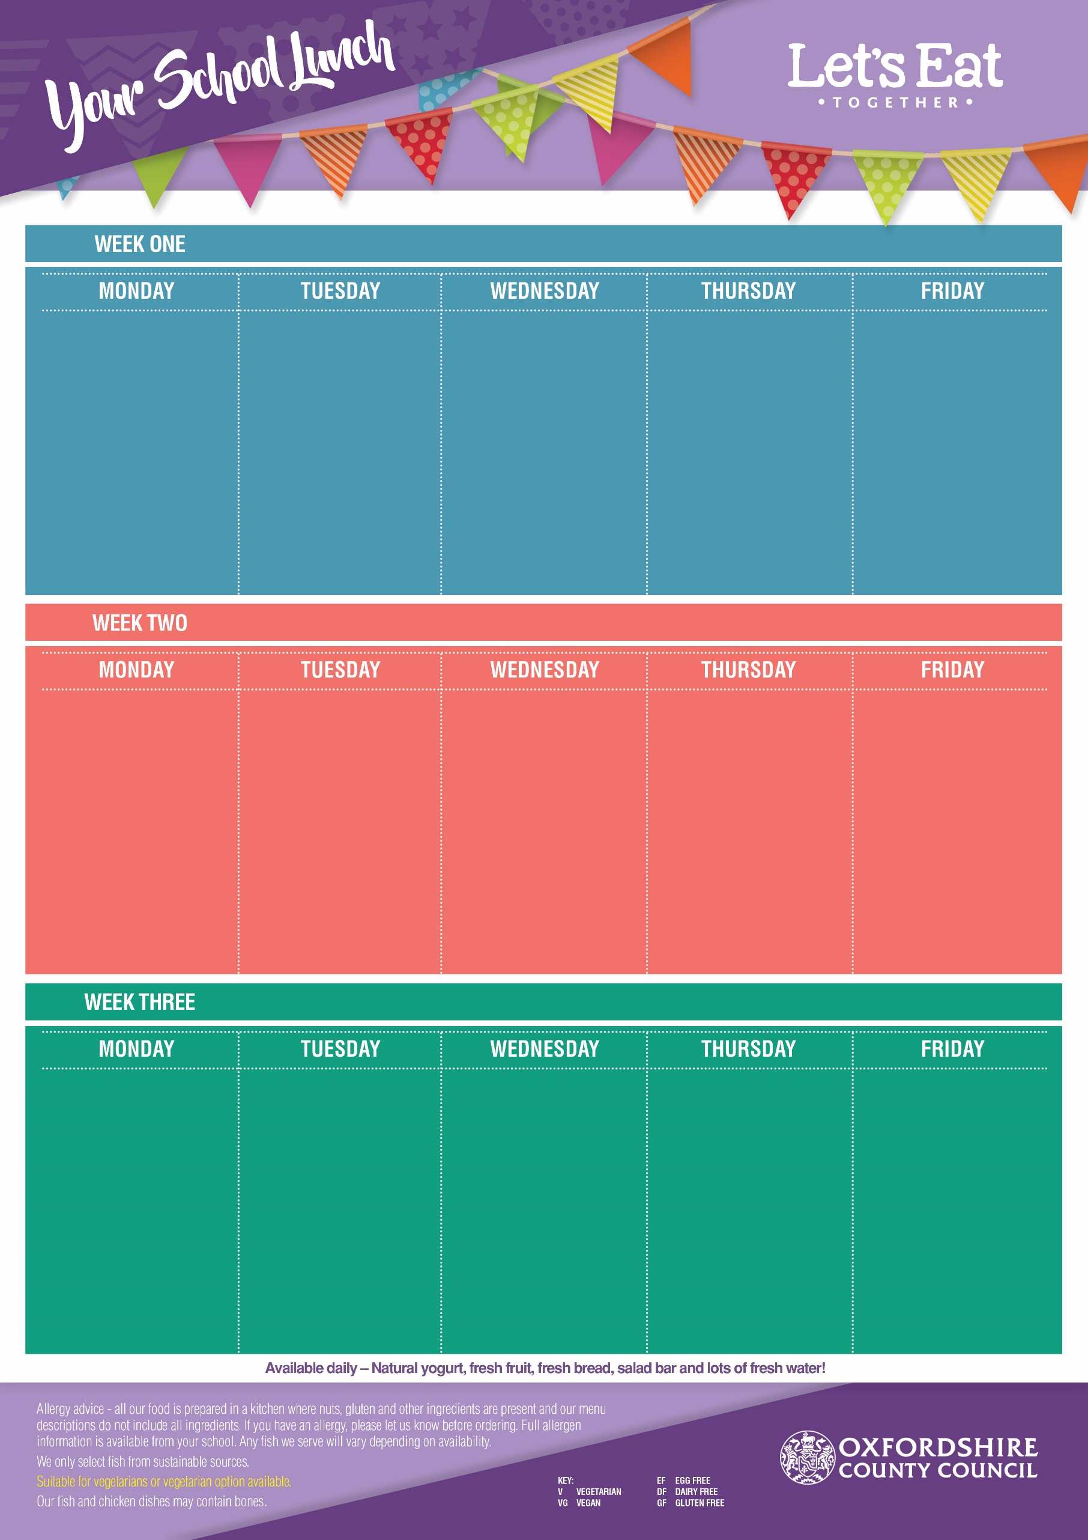

Flipper Dippers (DF, EF)
Veggie Samosa’s (VG)
Egg Mayo & Lettuce Wrap (V, DF)

French Fries or Pasta
Baked Beans
or Sweetcorn

Strawberry Ice Cream
(V, GF, EF)
with Melon

Margherita Pizza
(Cheese & Tomato) (V, EF)
Sweet Potato & Chickpea Curry with Rice (V, GF, EF)
Veggie Couscous Salad
(VG)

Sweetcorn
& Baked Beans

Vanilla Sponge
Cake
(V, DF)

20th April, 11th May, 8th June, 29th June, 20th July, 7th Sept, 28th Sept, 19th Oct
Roast Loin of Pork
(GF, DF, EF)
Quorn Roast (V, GF)
Wholemeal Cheese & Tomato Sandwich (V, EF)

Yorkshire Pudding, Roast Potatoes & Gravy
Carrots & Cabbage

Shortbread
(V, EF, DF)
with an Orange Wedge

Meatballs in a Tomato Sauce (GF, DF, EF)
Veggie Meatballs in a Tomato Sauce
(VG, GF,)
Baked Jacket Potato with Cheese (V, GF, EF) or Baked Beans (VG, GF)

Pasta,
Peas & Broccoli

Ginger Biscuit
(V, EF)

Pork Sausages with Gravy
(DF, EF)
Veggie Sausage with Gravy (VG, GF)

Baked Jacket Potato with Cheese (V, GF, EF) or
Baked Beans (VG, GF)

Mashed Potatoes (GF, EF)
Carrots & Cauliflower

Crunchy Cornflake Cookie
(EF, DF)

Chicken & Leek Pie
with New Potatoes
(DF, EF)
Sweet & Sour Veggie Noodles (V, DF)
Jacket Potato with Cheese (V, GF, EF) or Baked Beans (VG, GF)

Vegetable Medley & Broccoli

Cinnamon Cookie
(V, EF)

Margherita Pizza
(Cheese & Tomato) (V, EF)
Vegetable & Bean Chilli with Rice (VG)
Wholemeal Egg Mayo Sandwich (V, DF)

Sweetcorn &
Baked Beans

Lemon Oat Cookie
(V, EF, DF)
& Raisins

Beef Bolognese with Pasta (EF, DF)
Veggie Bolognese with Pasta (VG)
Jacket Potato with
Cheese (V, GF, EF) or Baked Beans (VG, GF)

Carrots & Green Beans

Iced Sprinkle Cake
(V, DF)

Chicken Nuggets (Ef, DF)
Veggie Sausage Roll (V, EF)
Breaded Salmon Wrap with Mayo & Lettuce (EF, DF)

Chips or Pasta
Peas &
Baked Beans

Vanilla Ice Cream
(V, GF, EF)
with Pineapple

Creamy Chicken Risotto
(GF, EF)
Veggie Sausage Pasta Bake (V, EF)
Baked Jacket Potato with Cheese (V, GF, EF) or Baked Beans (VG, GF)

Peas & Green Beans

Sultana & Syrup
Cookie
(V, EF)

27th April, 18th May, 15th June, 6th July, 14th Sept, 5th Oct
13th April, 4th May, 1st June, 22nd June, 13th July, 31st Aug, 2nd Sept, 12th Oct
Roast Gammon (GF, EF, DF)
Vegetarian Quorn Roast
(V, GF)
Tuna & Sweetcorn Wrap
(DF, EF)

Roast Potatoes & Yorkshire Pudding with Gravy

Savoy Cabbage
& Peas

Banana Cake
(V, DF)

Margherita Pizza
(Cheese & Tomato) (V, EF)
Spinach & Pepper Pasta (VG)
Wholemeal Cheese & Cucumber Sandwich (V, EF)

Sweetcorn &
Baked Beans

Melting Moment
(V, DF, EF)
with Mandarins

Roast Chicken Breast
(GF, DF, EF)
Quorn Roast
(V, GF)
Tuna & Cucumber
Pasta Salad (EF, DF)

Roast Potatoes,
Yorkshire Pudding,
Cauliflower & Peas

Cherry Biscuit
(V, EF)

Fish Fingers (DF, EF)
Cream Cheese & Broccoli Pinwheel (V, EF)
Veggie Pasta Salad
(VG)

Chips or Pasta
Peas &
Baked Beans

Strawberry Jelly
(V, GF, DF, EF)
with Peaches

Chicken Korma
with Rice (EF, GF)
Mac ’n’ Cheese (V, EF)

Jacket Potato with Cheese (V, GF, EF) or Baked Beans (VG, GF)

Carrots &
Sweetcorn

Rock Cake
(V)

