Aston and Cote Primary School – Knowledge Organiser 2022/2023
Subject: Maths | Year 5 | Term 3
Finding equivalent fractions
Equivalent fractions have the same value, even though they may look different.
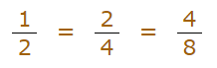
These fractions are actually the same.
How many equivalent fractions can you find in the fraction wall?

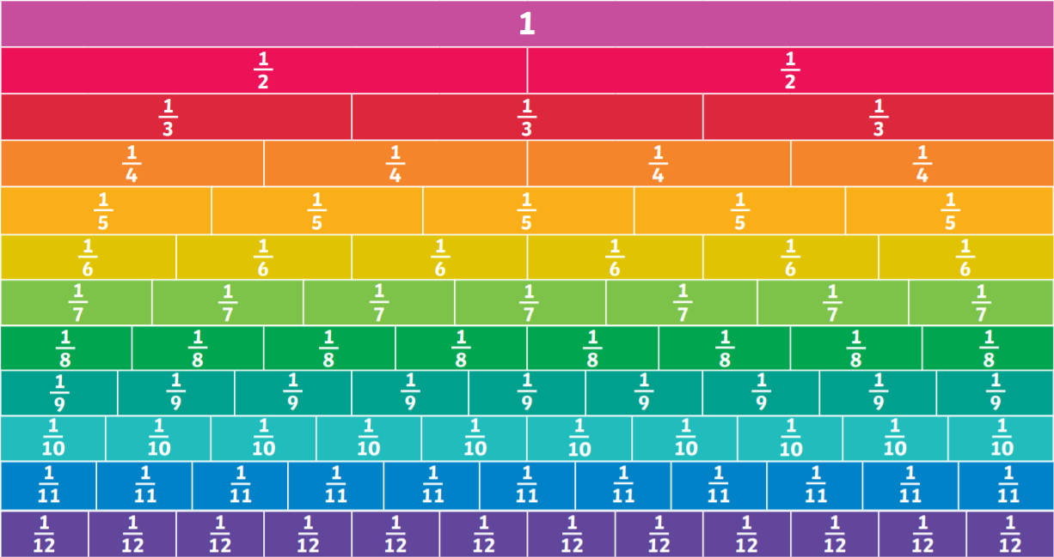

Why are they the same?
Because when you multiply or divide both the numerator and denominator by the same number, the fraction keeps its value.

Remember: Whatever you do to the bottom, you have to do to the top.

Using the fraction wall, can you see that
all take up the same amount of space?

What other fractions are equal to ?

What other equivalent fractions can you find?

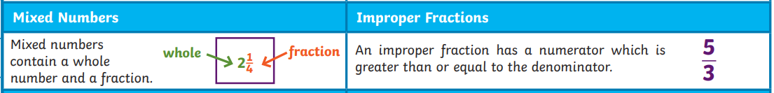

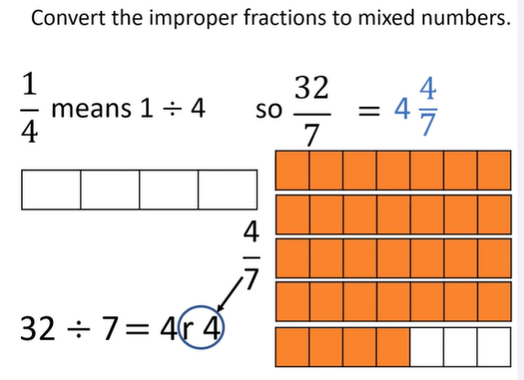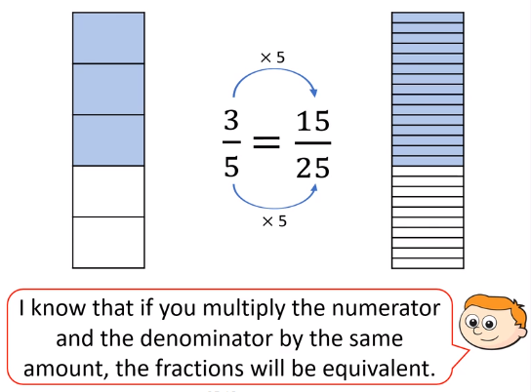
Adding and Subtracting fractions https://www.bbc.co.uk/bitesize/topics/zsxhfg8/articles/z4jg4qt
www.bbc.co.uk/bitesize/topics/zsxhfg8/articles/z4rhsrd



