Aston and Cote Primary School – Knowledge Organiser 2025/26 |  |  | 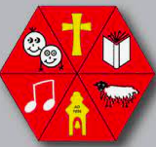
Subject: Maths | Year 6 | Term 4
Writing Fractions as Decimals
3/10 = 3 tenths. H T O . t
On a place value chart this looks like → 0 0 0 . 3
3/10 = 0.3

Sometimes, it’s easier to change the denominator to 10 or 100.

4/5 = 8/10 = 0.8 T O . t h
18/20 = 9/10 = 0.9
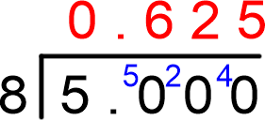
0 0 . 2 2
3/20 = 15/100 = 0.15
11/50 = 22/100 = 0.22
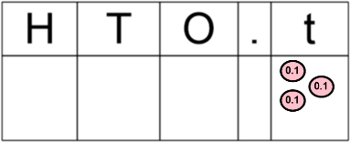
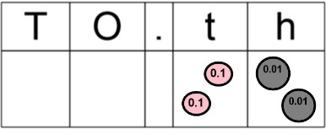
Write out 5 fractions
However, some fractions won’t be equivalent to 10 or 100, for example, 5/8. and write them as
A fraction bar means divide, therefore, 5/8 is the same as 5 ÷ 8. decimals, use the best
Then we can use our bus stop method. technique.
So we can say that 5/8 = 0.625. Challenge: give
yourself more fractions where you need the bus stop
Writing Fractions as Percentages method.
Percentage means out of 100. Therefore, we need to make our fraction’s denominator 100, and the numerator is the percentage.
Write out 5 fractions and write them
7/10 = 70/100 = 70% as percentages. Make the
2/5 = 4/10 = 40/100 = 40% denominator 100 each time.
17/25 = 34/50 = 68/100 = 68% Challenge: give yourself fractions that 9/20 = 45/100 = 45% require more steps (like the last 9/15 = 3/5 = 6/10 = 60/100 = 60% ^{example)}

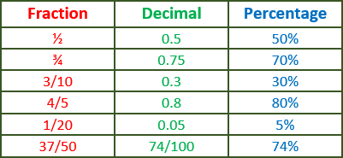
Fractions, Decimals and Percentages
Draw your own fraction, decimal, percentage table and add your own fractions. Write them as decimals and percentages.
Challenge: start by writing decimals and turn them into fractions and percentages

Percentages of Amounts 1 |  |  | Percentages of Amounts 2
Percentage means ‘out of a hundred’. For example, 76% |  |  | To find percentages that aren’t 50%,
means 76 out of a hundred and 100% means 100 out of a |  |  | 25% or 75%, it can be easier if we know
hundred. |  |  | what 10% and 1% of our first number is.
We can find 50%, 25% and 75% more easily. |  |  | 20% of 400
50% = ½, 25% = ¼, 75% = ¾ |  |  | 10% of 400 = 40, so 20% = 80
 |  |  | 20% of 400 = 80
50% of 80 = 40
Therefore, 25% of 80 = 20 |  |  | 35% of 250
And 75% of 80 = 60 |  |  | 10% of 250 = 25, so 30% = 75
 |  |  | 1% of 250 = 2.5, so 5% = 12.5
 |  |  | 35% of 250 = 82.5
50% of 20 = 10
25% of 60 = 15 |  |  | 62% of 90
75% of 208 = 156 |  |  | 10% of 90 = 9, so 60% = 54
 |  |  | 1% of 9 = 0.9, so 2% = 1.8
Come up with your own 5 numbers and find  50%, 25% and 75% of those numbers. |  |  | 62% of 90 = 55.8
Challenge: Start with an odd number. |  |  | 4% of 87  1% of 87 = 8.7, so 4% = 34.8
 |  |  | 4% of 87 = 34.8
Perimeter  Perimeter is the ‘path’ that surrounds a 2D shape.  Perimeter = | Area of a Square/Rectangle Area is the total amount within a 2D shape.  Area of a rectangle = |  |  | Area of a Parallelogram  A parallelogram is a 4-sided 2D shape with 2 pairs of parallel edges. Each parallel pair edge is the same length.
Length + Length + Width +  Width  or  (Length + Width) x 2 | Length x Width  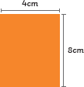  Example: |  |  | Area of a parallelogram = Width x Perpendicular Height
 |  |  |  | Example:
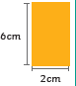
4 x 8 = 32cm²
Example: |  |  |  | 8 x 12 = 96cm²
6 + 6 + 2 + 2 =  16 cm  (6 + 2) x 2 = 16cm | Make sure you add a ‘squared’ ² |  |  | 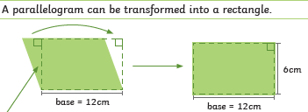
Area of a Triangle    If any two identical triangles are placed next to each other, we  can make a rectangle or parallelogram.  We know that the area of a parallelogram is Base x Height. |  | Volume of a Cuboid  Volume means the amount of space that an object occupies. We can only work out the volume of 3D shapes and objects.  To work out the volume of a cuboid, we can find the area of a face, then multiply it by the length of the cuboid.

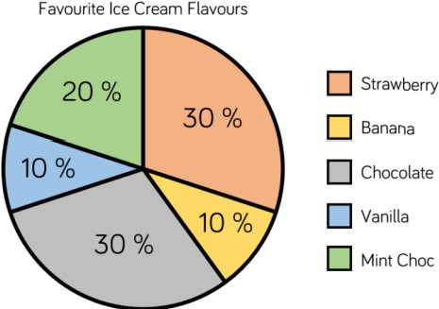
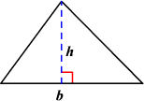
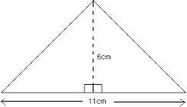
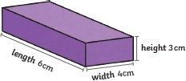
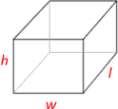
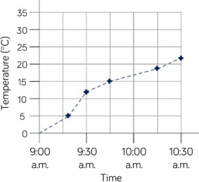

Therefore, to find the area of a triangle, we must half this.

Area of a Triangle = ½ x (Base x Height)

Example:

Volume of a Cuboid = Height x Width x Length
It doesn’t matter which measurement is the width, height or length, as we multiply them all together.
Example:

Area = ½ x (B x H)
= ½ x (11 x 6)
= ½ x 66
= 33cm²

Draw your own triangles with the base and height measurements, then work out the area of your triangles! Remember ½ (B x H)

Statistics
H = 3cm W = 4cm L = 6cm
Volume = 3 x 4 x 6
= 12 x 6
= 72cm³
When working out volume, we use cm³ (cubed), as our shape is 3D.

Draw your own cuboids and work out the volume. Remember to make your answer cubed³

In maths, there are a variety of ways that statistics and information can be represented. Take a look at how to interpret and read the following graphs and charts:

Line Graphs
Here is a line graph. Line graphs are created by plotting points onto the graph. In this example, the temperature at 9:30 was 12 degrees, so we plot a dot or cross in line with 9:30 and 12 degrees.
A line is then joined to connect the dots, like a dot-to-dot.

To read a line graph, we need to work in straight lines up and across the graph. If we wanted to know the temperature at 10:15, I find 10:15 on my x axis and draw a straight line up until I hit the line (see yellow). Then I draw a line straight across from that point until I hit
the y axis (green). Here I can now say that the temperature was roughly 19 degrees.

Make sure you are careful and know what the scale of your axis is. Does it go up in 1s, 2s, 5s, 10s, 100s?

Pie Charts

Draw your own line graph if you feel confident enough, but make sure you use a ruler for your axis and line! You could then ask yourself to find out some information based on your line graph. If you’re not so confident, try copying the example on the right.

Here is a pie chart. Pie charts are used to represent percentages. You can remember P for pie = P for percentage. As we’re working in percentages, the whole pie must equal 100%. In order to work out the percentage of people who like vanilla (blue), we must add all the other percentages together, then subtract from 100. 30+10+30+20=90, therefore we are left with 10% of people liking vanilla.

Pie charts don’t tell us how many people were in each group unless we’re told some information. If we were told that there were 50 people asked in total, then to find out how many liked chocolate, I would need to find 30% of 50 = 15.
However, sometimes we might only be told how many people are in one group. If we were told that 50 people liked Banana, then we can say that 10% = 50. Therefore 100% = 500, so 500 people were asked in total. We could then find out how many liked Mint Choc by finding 20% of 500 = 100 people.
The Mean
The term mean is the same as asking for the average. The mean number of marks on a paper means the average mark.

To work out the mean, we follow 2 simple steps:
- Add up all the values we have been given.
- Divide the total by however many values there were.
For Hasan’s mean score, I first add up all the values (134+60+17+63+38+84+11 = 407).
Then I divide 407 by how many scores there are (407 ÷ 7 = 58.14) So on average, Hasan scores 58.14 runs each match.
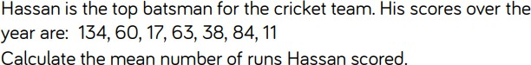
Come up with your own values and find the mean. Maybe you want to work out the mean height of everyone in your house or the mean length of your
friend’s pinky fingers. Remember to divide by how many values you have in
total.

