Aston and Cote – Knowledge Organiser 2025/26 |  |  | 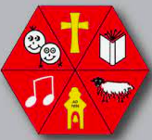
Subject: Maths | Year 6 | Term 3
Ratio and Proportion
Ratio is a format of showing the size of two or more quantities when compared to each other.

Notice how a colon : is used to show the difference.

We can also write these as fractions. I could say that of the ball in the top example, there is 1 football compared with 4 rugby balls, so there are ¼ as many footballs are rugby balls.
Draw your own pictures and show the ratio and fractional comparisons. Use the sentences: For every , I have .

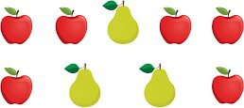
Simplifying Ratio

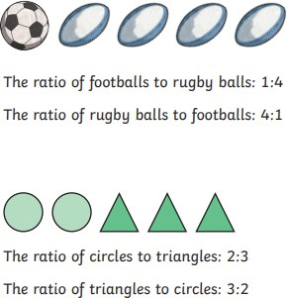
Sometimes we need to simplify ratios.




I could say the ratio is 6:3, but notice how for every 2 apples I have one pear? That’s because 6 can be divided by 3. So my simplified ratio is actually 2:1. The apples and pears would need to be split 2:1 a few times until all the apples and pears were used up.

Sharing with Ratio
Sometimes ratio can be used to show how the same items have been shared. Some ratios have more than 2 quantities.
An example of his could be sharing sweets. Emma has 12 sweets. She’s sharing them with the ratio 1:2:3 – this means for every 1 sweet her sister gets, her mum gets 2 sweets and Emma keeps 3 sweets.

However, after one round of sharing, Emma still has some sweets left over. So far Emma has shared 6 sweets, but she has another 6 sweets left, so she has to do another round of 1:2:3 sharing. Because she’s done 2 rounds of sharing, each person will have x2 as many
sweets as the currently have. Her sister will get 2
sweets (1x2=2), her mum will get 4 (2x2=4) and Emma will have 6 sweets (3x2=6). Notice how if I add up 2+4+6, I end up with 12 sweets, which is what Emma had to begin with.

Scale Factors
Scale factors relate to how much larger one quantity is compared to the other. For example, if I had £10 and my brother had £20, then the scale factor is 2 because £10 x 2 = £20. He has twice as much money as I do.

Sometimes we might get asked to work out the scale factor. If Sheila’s water bottle has 150ml left, and Frank’s bottle had 450ml left, then to work out the scale factor, we divide our largest value (450ml) by the other value (150ml). 450 ÷ 150 = 3, so the scale factor is 3. Frank has three times as much water as Sheila. I could also have counted up in 150s 3 times until I reached 450.
Come up with your own scale factor examples in your books and write out the scale factor.
Challenge yourself by making the scale factor a fraction e.g. ½. What would that look like?

Algebra
Algebra is a type of mathematics where unknown numbers are represented by letters until they become a known value.

The most simple version of an algebraic equation could be this:

6 + a = 11
I know that a = 5 because 6 + 5 = 11

Often, numbers and letters are written next to each other without a space. E.g. 5b = 10. This lack of space means these two are being multiplied together. So we could rewrite the equation as 5 x b = 10, therefore b = 2.
Come up with your own simple algebraic equations using the four functions (+ - x ÷) and write the solution.

Some equations will require us to do more than one function to work out an unknown value:

5a + 9 = 39
With these, it’s easier to see what’s going on if we draw a bar model:
39
9 | 5a

We know that adding 9 and 5a = 39. Therefore, to work out 5a, we can subtract 9 from both the top and bottom of our bars. This then leaves us with 5a = 30. This can be written as 5 x a = 30, so a = 6.
Remember: bar models work best with adding or subtracting equations!

Come up with your own algebraic equations using more than one function. Draw a bar model to show what the problem looks like, then solve it.

Finally, some algebraic equations might have more than one unknown and might have more than one solution:

2g + p = 11
It’s essential that we try some numbers to see what works. If g = 1, then we have 2 x 1 + p = 11, so p = 9
11
p | 2g

If g = 2, then we have 2 x 2 + p = 11, so p = 7 And so on.
However, I must stop at g = 6. If g = 6, then we have 2 x 6 + p = 11, and 2 x 6 = 12 so I have too much.
Come up with your own algebraic equations with multiple unknowns and multiple solutions. Draw a bar model then solve it.

Metric Units of Measure
Length
1 km = 1000 m
1 m = 100 cm
1 cm = 10 mm

Metric Units of Measure
Weight
1 tonne = 1000 kg
1 kg = 1000 g

Metric Units of Measure
Capacity
1 kL (kilolitre) = 1000 L
1 L = 1000 ml

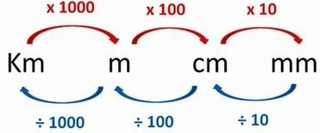
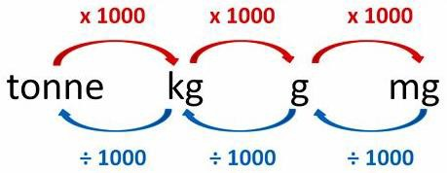
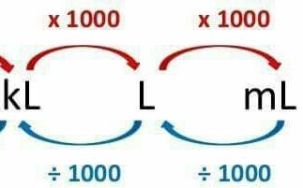
Come up with your own length measurements and find the equivalent measurements.
Come up with your own weight measurements and find the equivalent measurements.

Come up with your own capacity measurements and find the equivalent measurements.

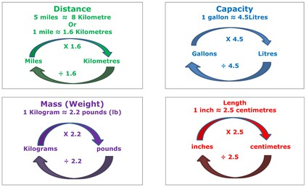
Imperial vs Metric

Sometimes, we use imperial measurements Instead of metric. Here are some equivalent measurements, the ≈ tell us it’s not exactly correct, but close enough to make it accurate.
If I know 5 miles ≈ 8 km, then I know… 10 miles ≈ 16 km
2.5 miles ≈ 4 km
100 miles ≈ 160 km

