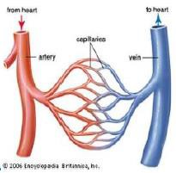
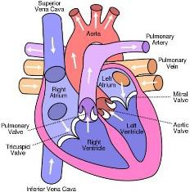
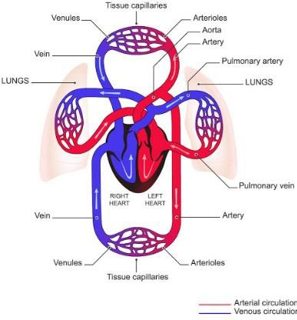
Aston and Cote CoE Primary School– Knowledge Organiser 2025/26
Subject: Science | Biology: The Circulatory  System | Year 6 | Term 1

What is the circulatory system?
The circulatory system is the system within our bodies that pumps blood to and from the heart.
The circulatory system is made up of the heart, the lungs and
blood vessels.
There are 3 main types of blood vessels in our circulatory system:
- Veins – The veins transport deoxygenated blood back to the heart, to be pumped across our bodies. The major vein leading back to the heart is called the Vena Cava.
- Arteries – The arteries transport oxygenated blood from the heart to the rest of the body. The major arteria leaving the heart is called the Aorta.
- Capillaries – The capillaries are where blood from the arteries brings nutrients and oxygen to the body, and where blood moves from arteries to
veins.
Factors that can harm our circulatory system
Some choices can be harmful to our circulatory system, for example:
- Smoking – Smoking can cause damage to the circulatory system. Smoking can cause the blood vessels to narrow and for less oxygen to be transported to the body, which makes it harder for the heart to pump blood around the body.
- Alcohol – Drinking alcohol can also cause damage to the circulatory system. Drinking too much alcohol can clog blood vessels, which makes it harder for the
heart to pump blood around the body.
Factors that can help our circulatory system
The best thing we can do to maintain a healthy heart and circulatory system is to exercise.
Exercise helps because it:
- reduces fat which makes it easier for the heart to pump blood around the body.
- strengthens the heart muscles which means more blood can be pumped around the body with each beat.
- increases the lungs capacity of oxygen, therefore more oxygen can be pumped around the body, and our muscles need oxygen to work properly.

The Heart
The human heart is made up of 4 chambers: The right and left atriums and the right and left ventricles.

Blood is collected into the atriums, then moves to the ventricles where the blood is pumped from the heart.
How the Circulatory system works
Deoxygenated blood enters the right atrium via the Vena Cava, moves to the right ventricle where blood is pumped to the lungs to collect oxygen.

Once blood had collected oxygen from the lungs, it enters the left atrium via the pulmonary veins, then moves to the left ventricle, where blood is pumped all over the body via the Aorta.

After, the blood drops off nutrients and oxygen to the capillaries, then it returns back to heart via the Vena Cava, and the process repeats.
Every time the blood is pumped, we call it a heartbeat or pulse.
 | Key vocabulary
 | Aorta | The major artery that carries oxygenated blood to the rest of the body.
 | Arteries | Blood vessels that transport oxygenated blood away from the heart.
 | Atrium | Chambers of the heart which take blood in.
 | Blood Vessels | Components that transport blood through the circulatory system: arteries, veins and  capillaries.
 | Capillaries | Blood vessels where nutrients and oxygen are dropped off around the body.
 | Deoxygenated | Blood that does not contain oxygen.
 | Heart | The organ that pumps blood around the circulatory system.
 | Lungs | The organ that provides oxygen to deoxygenated blood.
 | Oxygen | An electrical device that makes a buzzing  noise and is used for signalling
 | Pulse | The regular beating of blood throughout your body.
 | Veins | Blood vessels that transport deoxygenated blood back to the heart.
 | Vena Cava | The major vein that carried deoxygenated blood from the body to the heart.
 | Ventricles | Chambers of the heart which pump blood to either the lungs or the rest of the body.

