Aston and Cote CoE Primary School – Knowledge Organiser 2025/26
Subject: Maths | Year 6 | Term 1

Read and Write decimals up to 3 decimal places
Remember any digit after the decimal point is less than 1.
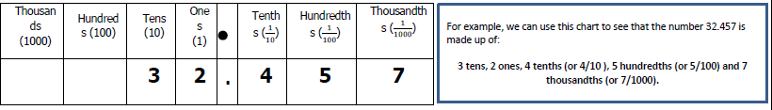
Challenge: Make up your own decimal number up to three decimal places and write the value of each digit.

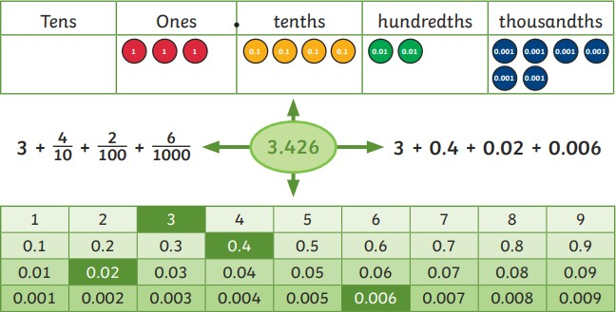
We can also use partitioning to help us read and write decimals.

Challenge: Can you partition the number you made from the previous challenge?
How many ways can you partition it?
 | Ordering decimals
Let’s look at an example:
Put these numbers in ascending order: 5.51, 3.75, 7.35, 5.73, 3.77 (ascending means from smallest to largest)
 |  | ones | . | Tenths  (1/10) | Hundredths  (1/100) |  | Look at the whole numbers first- the smallest whole is 3.  3.75 and 3.77 both have 7 tenths. Then we look at the hundredths column- one has 5 hundredths and then other has 7 hundredths so 3.75 is smaller.  5 is the next smallest whole number. 5.51 has 5 tenths and 5.73 has 7 tenths so 5.51 is smaller.
 |  | 5 | . | 5 | 1
 |  | 3 | . | 7 | 5
 |  | 7 | . | 3 | 5
 |  | 5 | . | 7 | 3
 |  | 3 | . | 7 | 7
The decimal numbers from smallest to largest is
3.75 3.77 5.51 5.73 7.35
Challenge: Order the following numbers from smallest to greatest:
5.71 8.22 8.01 8.91 8.32 8.5

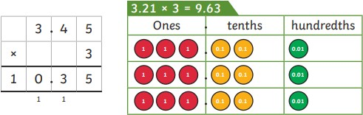
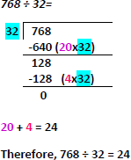
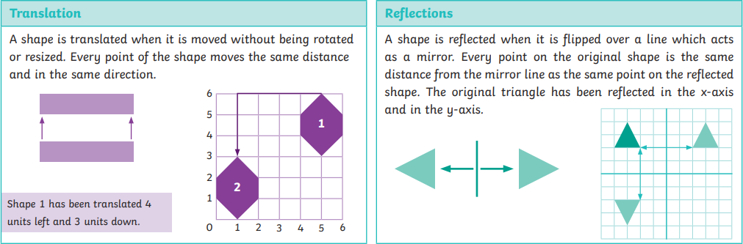
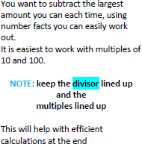

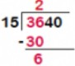
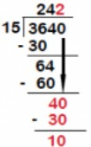
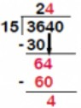
Multiply a decimal by a whole number

Challenge: Make up your own number with two decimal places.
Multiply the number by:
3, 5, 7 and 9

Division
Challenge: Make up your own 3- digit or 4-digit number and divide by a 2-digit number, using chunking and long division.

Long division
15 into 3 is not possible so we move the 3 to the next column.
15 goes in 36 two times so write 2 on top of the 6.
15 X 2 = 30 and 36- 30 = 6

Drop the 0 down to make 40.
15 goes in 40 two times so write 2 on top of 0.
15 X2 = 30 and 40 – 30 –
10

Position and Direction
Drop the 4 down to make 64.
15 goes into 64 four times so write 4 on top of the 4.
15 X 4 = 60 and 64 – 60 - 4

Challenge: Draw a four-sided shape on the grid in your book. Reflect it into each of the quadrants

