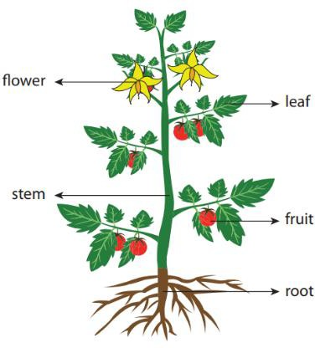
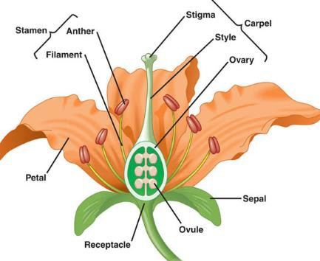
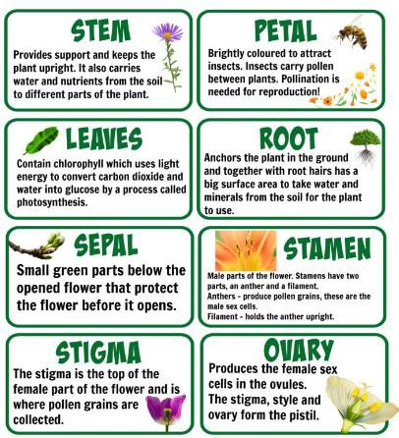
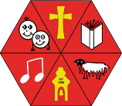
Aston & Cote Primary School – Knowledge Organiser

Science: Biology - Plants Year 3

Key Vocabulary

roots stem

leaf/leaves
The roots anchor or hold the plant in the soil. They take up (absorb) water and dissolved mineral salts.
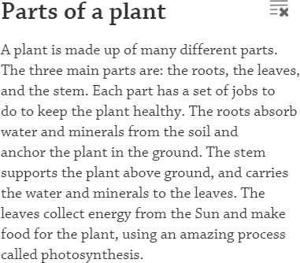
The stem supports the flower and the leaves, holding them up to the sunlight. Water travels from the roots through the stem to all the other parts of the plant.
How does water move through a plant?
The roots absorb water through the soil which then travels up the stem to different parts of the plant. When water forms on the leaves, it evaporates into the air which then causes more water to be sucked up through the stem, like water being sucked through a straw. This process is called transpiration.
The leaf is one of the most important parts of a plant. Leaves produce food for the plant through a process
called photosynthesis. The leaves of different plants vary widely in size, shape, and colour.

flowers

nutrients evaporation absorb
Flowers are the part of the plant that is usually brightly coloured and often scented (smell nice). Bright colours and scent help to attract insects.
Something in soil that helps plants to live and grow. When water is turned into a gas or vapour.
What do plants need to grow?
Room to grow - All plants like to have space to grow so leaves can expand and carry out the job of making food. Roots also need room to grow.
Temperature - Some plants prefer warmer temperatures while others may prefer cooler temperatures for best growth. Most plants like to have cooler temperatures at night.
Light - Plants need lots of light to grow. If it doesn’t get enough light, its stem will be thin and it will lean toward the light.
Water - is important in the plant's ability to make and move nutrients. Without water or with too much water, a plant dies. How often you water depends on a lot of things. Plant size, time of the year, and type of plant are a few.
Air -Plants use carbon dioxide in the air and return oxygen. Smoke, gases, and air pollution can damage plants.
Nutrients - Most of the nutrients that a plant needs are dissolved in water and then taken up by the plant through its roots.
Time - It takes time to grow and care for plants. Some plants require more time to grow than others. Getting plants to flower or fruit at a certain time can be challenging.
Soil is made of fine grains of rock which is mixed with air, water and tiny grains of dead plants and animals. There are three main types of soil which are identified by the amount of sand and clay in them.
To suck up or soak up water and nutrients.

