
Aston & Cote Primary School – Knowledge Organiser
Maths | Year 3 | Term 5

Measurement: Time |  | Money
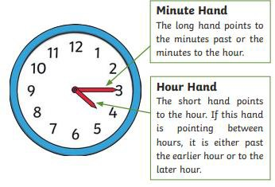 | Roman numerals Practice writing Roman numerals 1 to 12  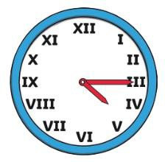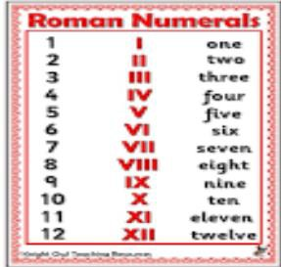 | 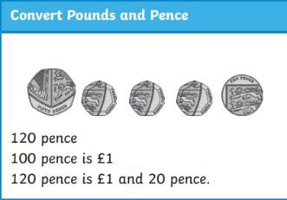  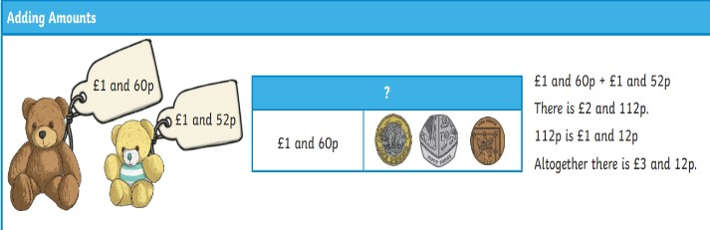  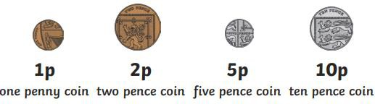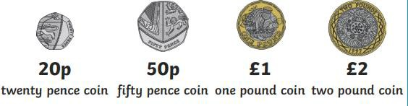  Convert these to pounds and pence. 435 pence  319 pence  721 pence
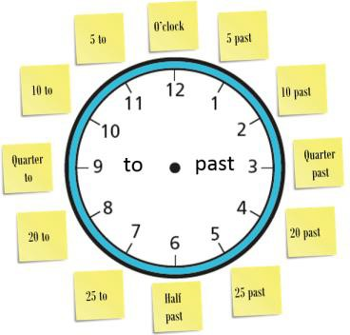  Analogue and digital  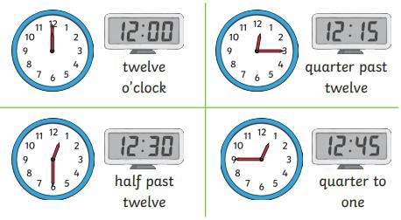 | Comparing duration  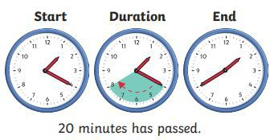  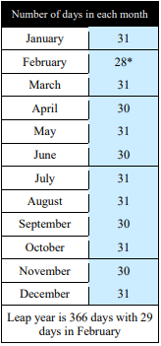  30 days has September, April, June and November, All the rest have 31, Except February alone.  Which only has but 28 days clear And 29 in each leap year  A leap year is every 4 years. The last leap year was 2020. The next leap year is 2024.  Learn the poem off by heart then test yourself by picking a month and guessing the number of days. | Add these amounts.  £1 and 40p + £2 and 46p  £2 and 58p + £3 and 55p  £2 and 39p + £1 and 66p  £3 and 44p + £2 and 61p  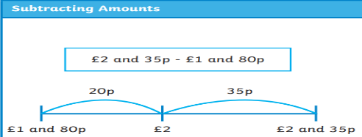  Subtract these amounts  £2 and 14p - £1 and 34p  £3 and 86p - £1 and 92p  £6 and 37p - £4 and 39p
 |  | Written multiplication |  | Bus stop division
 |  | 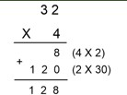 | Try these: 34 x 3  45 x 4  72 x 3  63 x 5 | 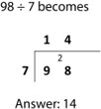 | Try these  105 divided by 3  128 divided by 4  90 divided by 5

Mass | Capacity
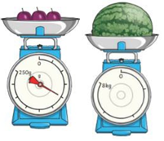Measure and Compare Mass: Scales can be used to measure mass in grams or  kilograms.  A gram/kilograms are units of measurement that are used to measure the mass of something.  Grams can be written as g. Kilograms can be written as kg  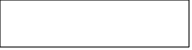Kilo means ‘thousand’ so it  means a thousand grams. 1000g = 1kg  If I know that 1000g = 1kg then I know 500g = 1/2kg because half of 1000 is 500.  To compare mass, we use the words heavier than > and lighter than <  When measuring mass on scales you need to work out what the scales are going up in -  the intervals.  Adding and subtracting mass  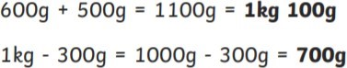  Challenge! Add and subtract these.  400g + 700g = kg g 2kg 100g – 300g = kg g Come up with your own additions and subtractions for mass? | Measure and Compare Capacity:  Capacity is the amount of liquid a container can hold.  Volume is how much liquid is in the container.  Smaller volumes are measured in millilitres in measuring cylinders. Greater volumes are measured in litres and these tend to be in measuring jugs.  Millilitres can be written as ml.  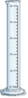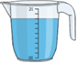Litres can be written as l.  Milli means ‘thousand’ so it  means a thousand litres. 1000ml = 1L  Can you think of a – ‘If I know that…’ statement?  To compare capacities, we can use the words full or empty.  When measuring volume on scales you need to work out what the scales are going up in - the intervals.  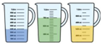Adding and subtracting mass  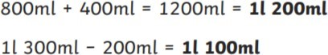  Challenge! Add and subtract these.  600ml + 600ml = L ml 1L 100ml – 300ml = ml  Come up with your own additions and subtractions for capacity?

