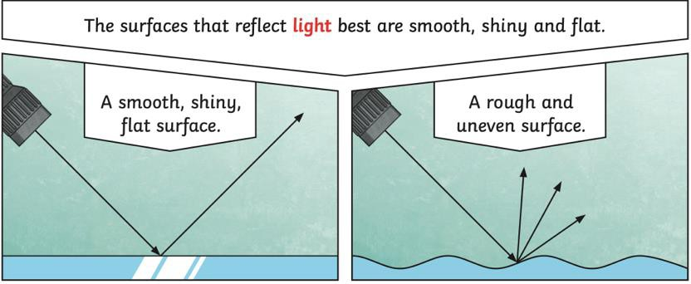
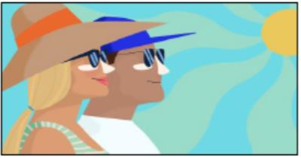
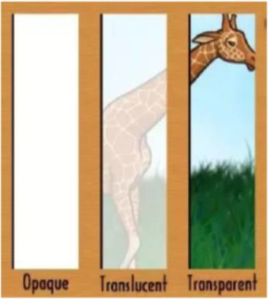
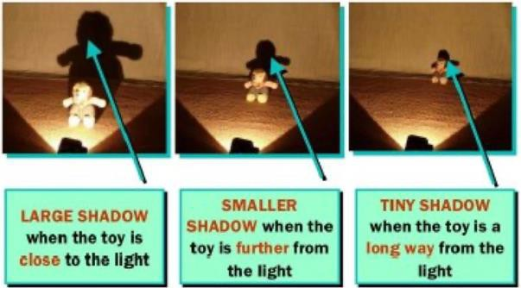
#
Transparent, Translucent & Opaque
A transparent object allows all the light to pass through it, making it completely see-through. Windows and water are transparent.
A translucent object only allows some light to pass through, meaning we can only partially see through them. Tracing paper and ice are both translucent.
An opaque object doesn’t allow any light to pass through it, meaning we cannot see through them at all. Bricks and books are both opaque.
Can you think of any more examples?
What is Reflection?
When light from an object is reflected by a surface, it changes direction.
Dull or dark surfaces don’t reflect light well, like dark fabrics.
Smooth, shiny or flat surfaces reflect light better than rough or uneven surfaces.
Reflective materials can help us keep safe by helping us see when it is dark. They reflect light to help us see road signs or cyclists when it is dark.
Can you think of any other examples of reflection in real life?
What is Light?
Light is a type of energy that lets us see things.
If there is no light, it is dark which means we can’t see anything.
Light comes from light sources, like the Sun, fires and lamps. Some animals, like fireflies and glow-worms are also light sources.

Can you find any sources of light where you live?
Sunlight
The bright light from the sun can be dangerous and can damage our eyes.
We must never look directly at the sun, as this can hurt our eyes.
We can protect our eyes by wearing sunglasses or hats in bright sunlight and making sure we don’t look directly at the sun.
Aston & Cote Primary School – Knowledge Organiser
Subject: Science | Topic: Light | Year 3 | Term 4

Key Vocabulary - Light |  | Light
Light | A type of energy that means we can see things. | Light
Light | A type of energy that means we can see things. | Shadow  A shadow is made when light is blocked by an opaque object.  The closer the object is to the light source, the larger the shadow will be. This is because the object blocks more of the light.  Could you use a light to make shadows, or draw some shadows?
Shadow | An area of darkness where the light has been  blocked.
Reflection | When light hits the surface of an object and  bounces back into our eyes.
Dark | The absence of light.
Reflective | Something that reflects light well, like a
Light Source | An object that produces its own light (sun, fire) | Mirrors  Mirrors can reflect very well. When the light hits the mirror, it creates a clear image in reverse.  Can you try to draw an object in a mirror?
Transparent | An object that allows light to pass through it,  meaning we can see through it.
Translucent | An object that allows some light to pass through it, meaning we can partially see through it.
Opaque | An object that doesn’t allow light to pass through  it, meaning we can’t see through it.



