
Aston & Cote Primary School – Knowledge Organiser
Maths – Fractions | Year 3 | Term 4

Key Vocabulary - Fractions |  | Comparing fractions | Equivalent fractions
fraction | An equal part of a whole. | Challenge! Write two fractions with the same denominator. Compare them using <,  > or =.  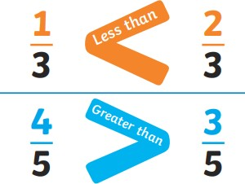 | 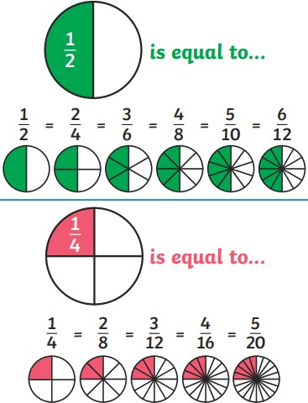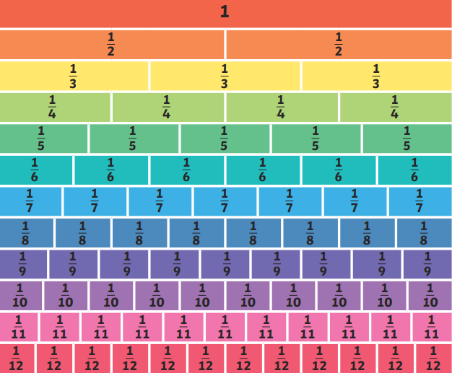  Challenge! How many fractions can you find that are equivalent to…  1 1 1 1  2 4 3 5
numerator | The top part of a fraction. This gives the number of parts shaded or selected.
denominator | The bottom part of a fraction. This gives the number of equal parts the  whole is divided into.
unit fraction | A fraction where the numerator is 1.
non-unit fraction | A fraction where the numerator is greater than  1.
equivalent | Equal to or the same.
Challenge! Quiz yourself – can you remember the definitions of each of the words above?
Recognising fractions |  |  | Counting in tenths
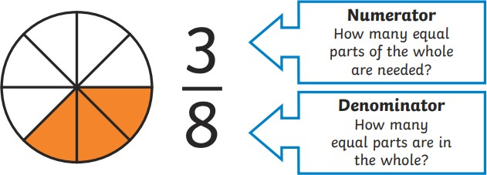  Challenge! Choose a fraction. Can you represent it as a shape like in the example above? Explain what the denominator and the numerator show. |  |  | 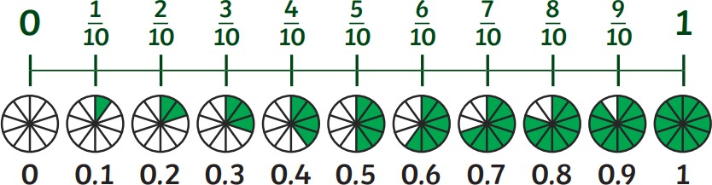  When adding or subtracting fractions with the same denominator – add or subtract the numerators and keep the denominators the same.  Challenge! Practise counting up and down in tenths

Mass | Capacity
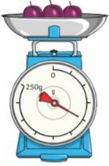  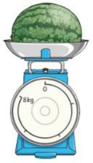  Measure and Compare Mass:  Scales can be used to measure mass in grams or  kilograms.  A gram/kilograms are units of measurement that are used to measure the mass of something.  Grams can be written as g. Kilograms can be written as kg  Kilo means ‘thousand’ so it  means a thousand grams. 1000g = 1kg  If I know that 1000g = 1kg then I know 500g = 1/2kg because half of 1000 is 500.  To compare mass, we use the words heavier than > and lighter than <  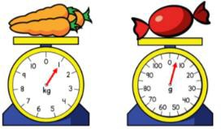  When measuring mass on scales you need to work out what the scales are going up in -  the intervals.  Adding and subtracting mass  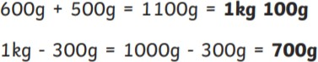  Challenge! Add and subtract these.  400g + 700g = kg g 2kg 100g – 300g = kg g Come up with your own additions and subtractions for mass? | Measure and Compare Capacity:  Capacity is the amount of liquid a container can hold.  Volume is how much liquid is in the container.  Smaller volumes are measured in millilitres in measuring cylinders. Greater volumes are measured in litres and these tend to be in measuring jugs.  Millilitres can be written as ml.  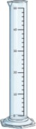  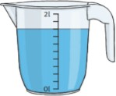  Litres can be written as l.  Milli means ‘thousand’ so it  means a thousand litres. 1000ml = 1L  Can you think of a – ‘If I know that…’ statement?  To compare capacities, we can use the words full or empty.  When measuring volume on scales you need to work out what the scales are going up in - the intervals.  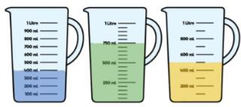  Adding and subtracting mass  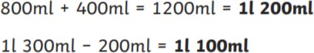  Challenge! Add and subtract these.  600ml + 600ml = L ml 1L 100ml – 300ml = ml  Come up with your own additions and subtractions for capacity?

