Aston & Cote Primary School – Knowledge Organiser
English |  | Year 3 |  | Term 4
Word Class 1 | Punctuation |  | Spellings |  |   Grammar
Fronted adverbial: A fronted adverbial includes words or phrases, which add some extra information to a sentence. The adverbial words or phrases are placed at the start of the sentence and come before the verb. For example, 'later in the evening, I found my missing cat'.  Write a short adventure story . write one paragraph each time you have a grammar day and start each paragraph with a new fronted adverbial (this can be an adverbial of time, manner or place.)  Inverted commas: When you are writing, inverted commas or speech marks go before and after direct speech, surrounding what was said. "I'm hungry," she complained. If another character replies, use another set of inverted commas. "What's for tea?" she asked. "Delicious ants!" her mum replied.  Write a short adventure story, write one paragraph each time and start each paragraph with a new fronted adverbial (see support sheet.) Add some speech into your story to show what your characters are saying! | Paragraphs: A paragraph is kind of like a group of friends. Paragraphs  are groups of sentences that share a common idea. They are all written about a certain topic, just like friends usually share a common interest. Paragraphs often include examples or evidence to support a topic, idea, or opinion.  Write a short adventure story, write one paragraph each time and start each paragraph with a new fronted adverbial. Add some speech into your story to show what your characters are saying! Arrange your story into paragraphs.  Story topics / themes: Choose 1 for your story and build your story up over the weeks:  - A castle adventure  - A journey to an unknown land  - An underwater adventure  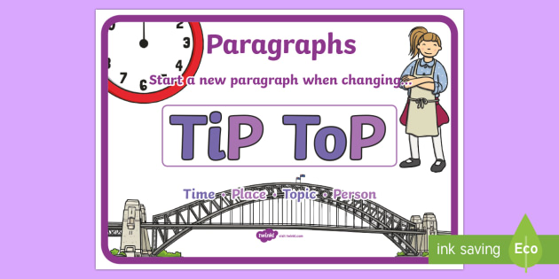 |  | Spellings:  Practice the spellings below. You could use look, cover write, check and you could put the  spellings into sentences.  Heard, heart, sentence, height, history, separate, imagine, important, special, increase, interest, island, learn, guide, guard, length, library, straight |  | Using a or an correctly:  The general rule for when to use a or an is that "a" is used before a word that begins with a consonant or a vowel that sounds like a consonant, while "an" is used before a word that begins with a vowel or a consonant with a vowel sound like the h in hour.  Find some objects and sort them into columns to show whether they should be a or an.  Present perfect tense:  The present perfect tense is used to describe actions that happened in the past but that are related to the present. To form the present perfect tense, we use the words 'has' or 'have' and add them to the beginning of a past tense verb.  Can you write about what you have been doing using the present perfect tense?  

