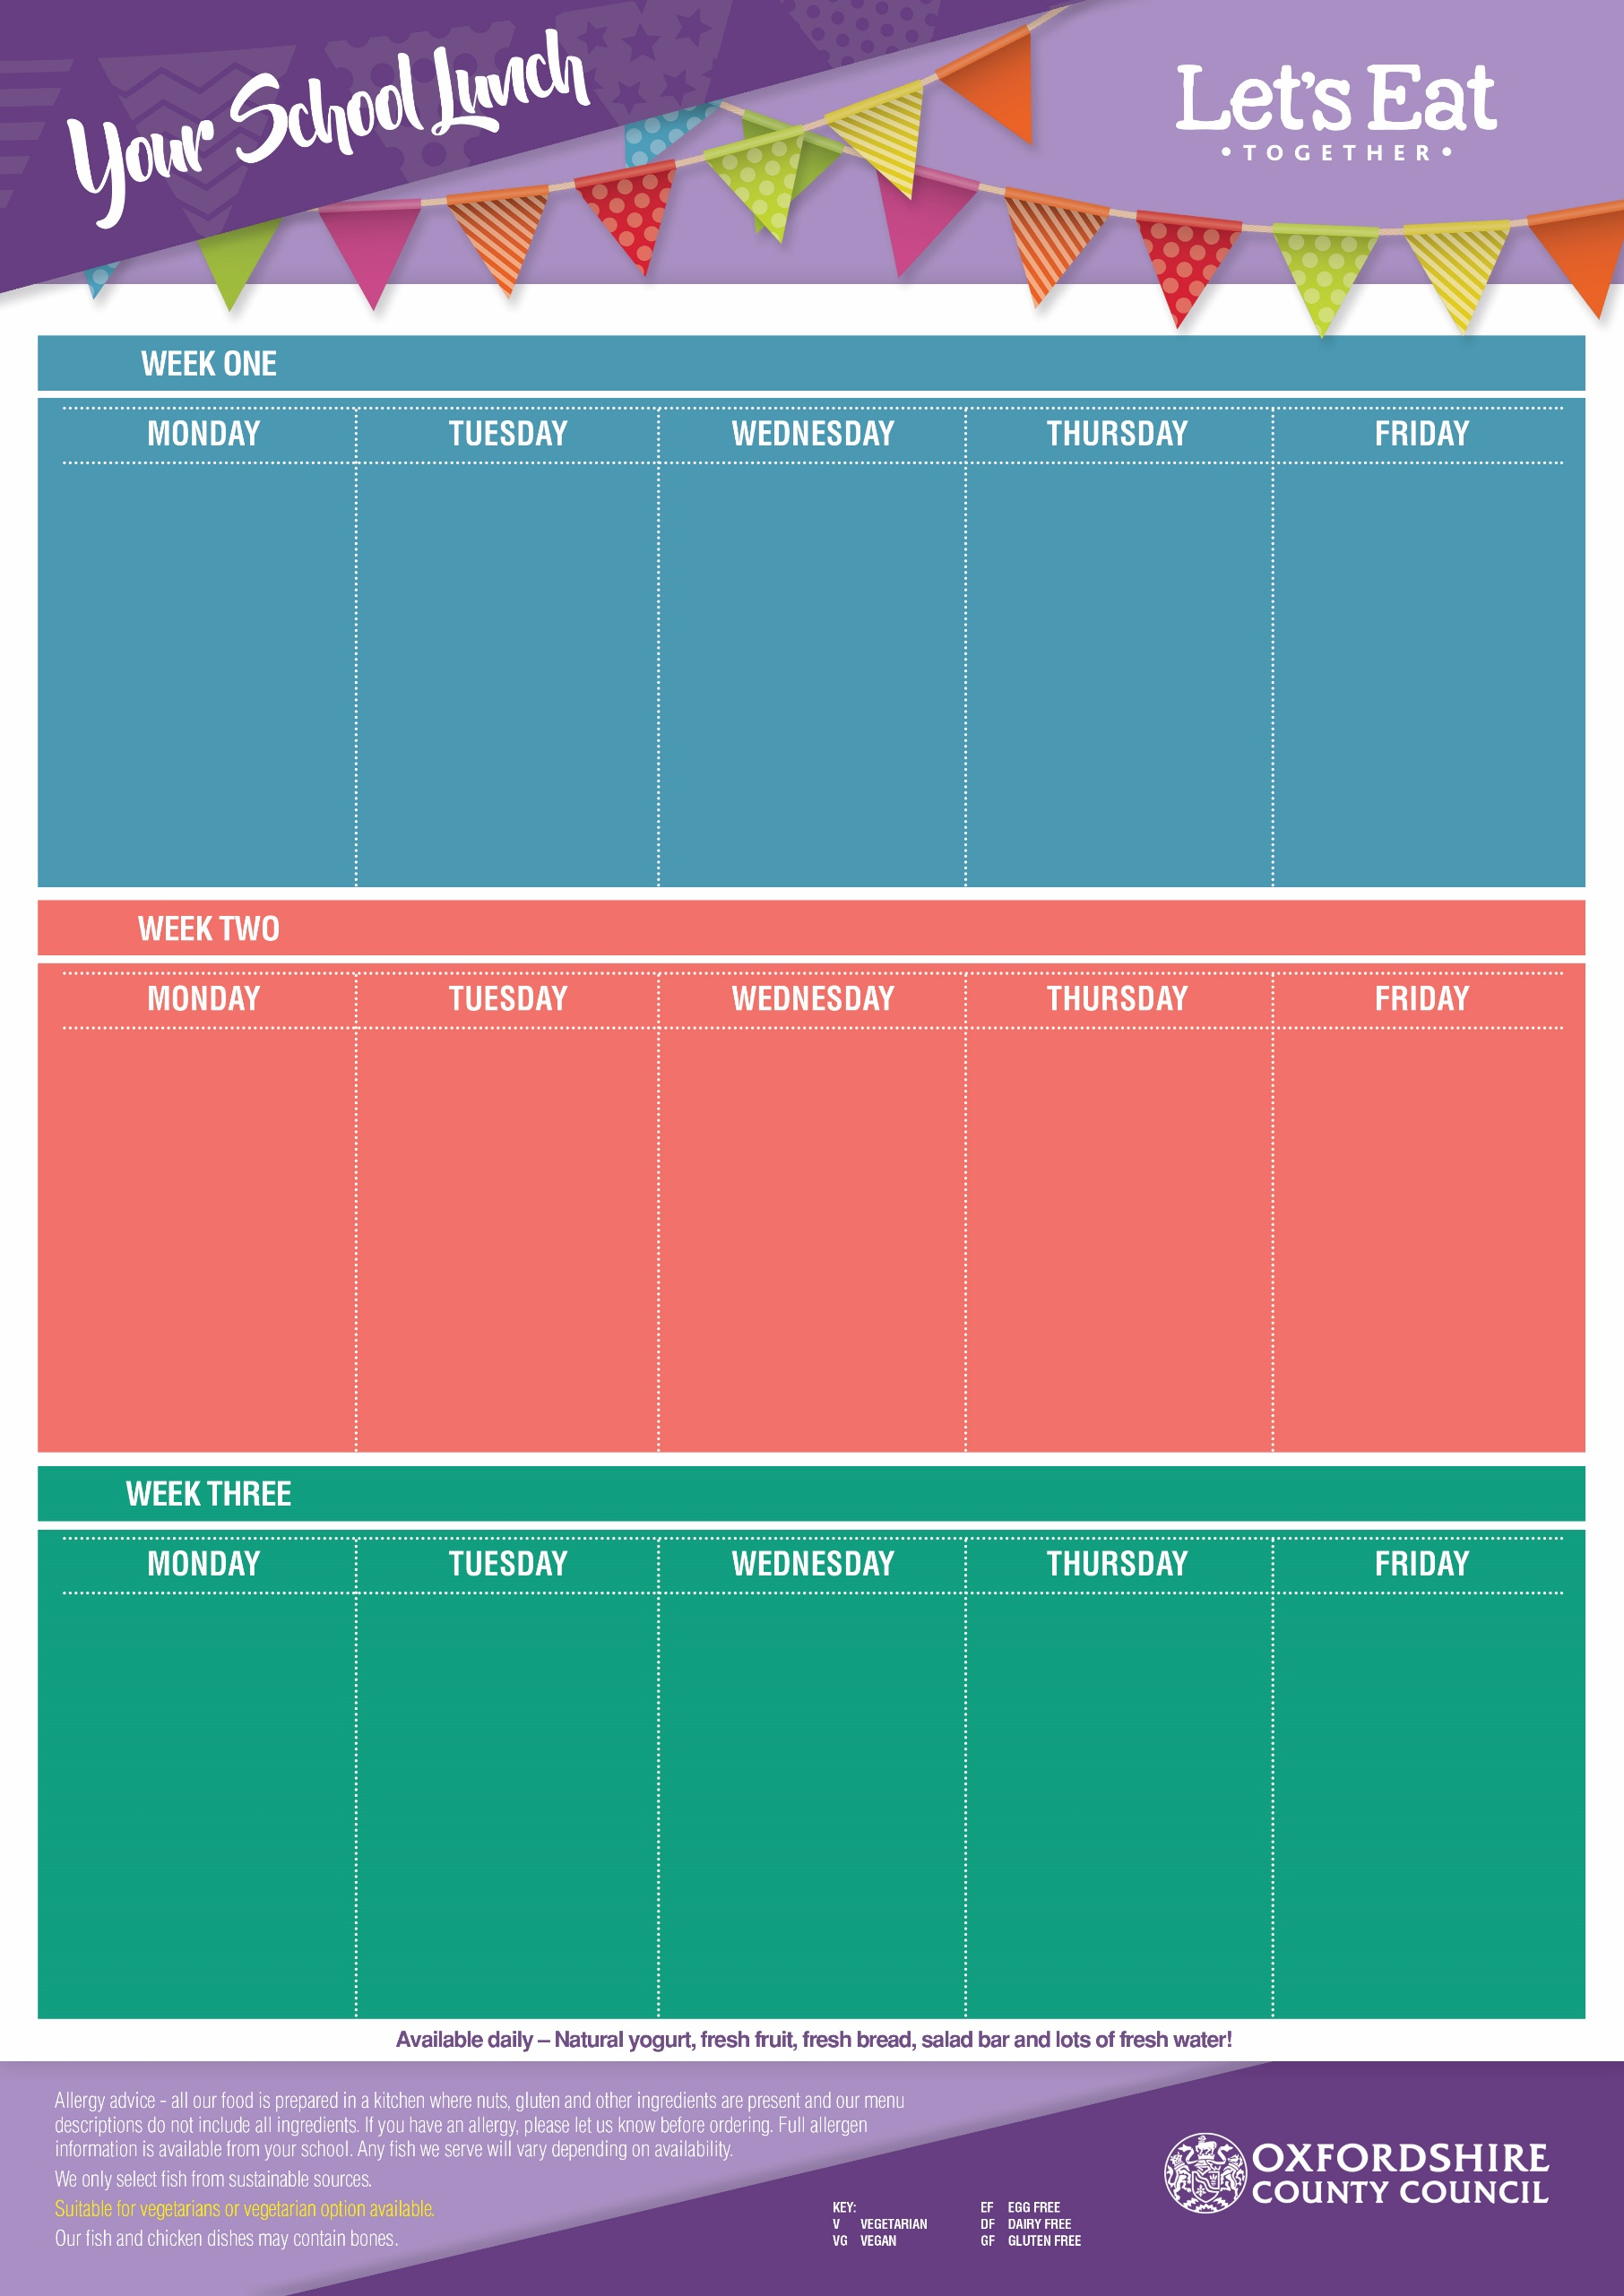

British Beef Burger

in a Bun *(DF, EF)*

Veggie Burger in a Bun

*(V, DF, EF)*

Baked Jacket Potato with Cheese (*V, GF, EF)* or Baked Beans *(VG, GF)*

Potato Wedges, Sweetcorn & Green Beans

Ginger Biscuit

*(V, EF)* with Melon

Chicken Korma *(GF, EF)* with Rice

Cheese & Red Onion Pinwheel *(V, EF)*

with New Potatoes

Baked Jacket Potato with Cheese (*V, GF, EF)* or Baked Beans *(VG, GF)*

Broccoli & Vegetable Medley

Chocolate Cornflake Cake *(V, DF, EF)*

Margherita Pizza

(Cheese & Tomato*) (V, EF)*

Spinach & Pepper Pasta *(VG)*

Cheddar Cheese

& Lettuce Wrap *(V, EF)*

Sweetcorn &

Baked Beans

Vanilla Sponge

Cake

*(V, DF)*

**28th April, 19th May, 16th June, 7th July, 8th Sept, 29th Sept, 20th Oct**

Creamy Garlic Chicken with Pasta *(EF)*

Mac ’n’ Cheese *(V, EF)*

Oven Baked Jacket Potato with

Cheese (*V, GF, EF)* or Baked Beans *(VG, GF)*

Carrots & Peas

Flapjack *(V, EF, DF)*

& Raisins

Fish Fingers *(DF, EF)*

Veggie Samosa’s *(VG)*

Cheddar Cheese

& Tomato Bap *(V, EF)*

Chips or Pasta

Peas &

Baked Beans

Iced Fruit

Smoothie

*(V, GF, EF, DF)*

Sticky BBQ Pork

*(GF, EF, DF)* with Rice

Veggie Sausage & Tomato Pasta Bake

*(V, EF)*

Baked Jacket Potato with Cheese & Coleslaw

(*V, GF, EF)*

Peas & Green Beans

Iced Sprinkle

Cake *(V, DF)*

**5th May, 2nd June, 23rd June, 14th July, 15th Sept, 6th Oct**

**21st April, 12th May, 9th June, 30th June, 21st July, 1st Sept, 22nd Sept, 13th Oct**

Roast Loin of Pork

*(GF, DF, EF)*

Vegetarian Quorn Roast

*(V, GF)*

Tuna & Cucumber

Pasta Salad *(DF, EF)*

Roast Potatoes & Yorkshire Pudding with Gravy

Savoy Cabbage & Carrots

Cranberry & Oat Cookie

*(V, EF)*

Margherita Pizza

(Cheese & Tomato) (V, *EF)*

Bean & Vegetable Chilli with Rice *(VG, GF)*

Cheddar Cheese & Cucumber Bap *(V, EF)*

Sweetcorn &

Baked Beans

Lemon Sponge

Cake *(V, DF)*

Beef Bolognaise *(DF, EF)*

Veggie Bolognaise *(V, DF)*

Baked Jacket Potato with Cheese (*V, GF, EF)* or Baked Beans *(VG, GF)*

Pasta, Sweetcorn & Broccoli

Melting Moment

*(V, DF, EF)*

with Pineapple

Pork Sausages & Gravy *(EF)*

Veggie Sausage

& Gravy *(VG)*

Rainbow Pasta

Salad *(VG)*

Mashed Potatoes,

Curly Cabbage &

Green Beans

Sultana & Syrup

Cookie *(V, EF)*

Fish Fingers *(DF, EF)*

Veggie Sausage Roll *(V, EF)*

Egg Mayo & Lettuce Bap

*(V, DF)*

Chips or Pasta

Peas &

Baked Beans

Vanilla Ice Cream

*(V, GF, EF)*

with Mandarins

Margherita Pizza

(Cheese & Tomato*) (V, EF)*

Cheese & Potato Pie

*(V, GF)*

Egg Mayo &

Lettuce Bap *(V, DF)*

Peas & Baked Beans

Shortbread

*(V, EF, DF)*

with an

Orange Wedge

Roast Chicken Breast

*(GF, DF, EF)*

Vegetarian Quorn Roast

*(V, GF)*

Breaded Salmon Wrap with Mayo & Lettuce *(EF, DF)*

Yorkshire Pudding, Roast Potatoes & Gravy

Carrots & Cauliflower

Chewy Vanilla Cookie

*(V, EF)*

Flipper Dippers *(DF, EF)*

Veggie Nuggets *(VG)*

Tuna & Sweetcorn

Wrap *(DF, EF)*

French Fries or Pasta

Baked Beans

or Sweetcorn

Cinnamon Swirl

*(V, DF, EF)*

With Peaches

Chicken & Leek Pie

*(EF, DF)* with New Potatoes

Sweet Potato & Chickpea Curry *(V, GF, EF)* with Rice

Baked Jacket Potato with Cheese (*V, GF, EF)* or Baked Beans *(VG, GF)*

Broccoli & Sweetcorn

Strawberry Jelly

*(V, GF, DF, EF)*

with Peaches