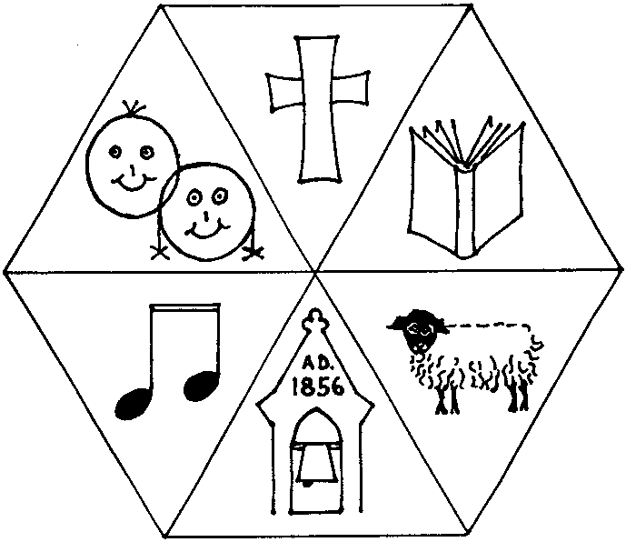**Aston and Cote Church of England Primary School**

“Aspiring to be the people God created us to be by growing the talents He gave us.”

Cote Road

Tel: 01993 850435 Aston

Email: [office.3120@aston-and-cote.oxon.sch.uk](mailto:office.3120@aston-and-cote.oxon.sch.uk) Bampton

Website: [www.aston-and-cote.oxon.sch.uk](http://www.aston-and-cote.oxon.sch.uk) Oxfordshire

Headteacher: Mrs Fiona Taylor OX18 2DU

Dear Parent / Carer,

**FREE SCHOOL MEALS / PUPIL PREMIUM**

As you may be aware, all children in Foundation Stage, Year 1 and Year 2 are entitled to Free School Meals. Existing entitlements for Free School Meals in KS2 continue as before, based on the existing Free School Meals eligibility criteria.

Under the current criteria, children whose parents receive one or more of the following support payments are entitled to receive Free School Meals.

* Income Support
* income-based Jobseeker’s Allowance
* income-related Employment and Support Allowance
* support under Part VI of the Immigration and Asylum Act 1999
* the guaranteed element of Pension Credit
* Child Tax Credit (provided you’re not also entitled to Working Tax Credit and have an annual gross income of no more than £16,190)
* Working Tax Credit run-on - paid for 4 weeks after you stop qualifying for Working Tax Credit
* Universal Credit - if you apply on or after 1 April 2018 your household income must be less than £7,400 a year (after tax and not including any benefits you get)

Your child might also get free school meals if you get any of these benefits and your child is both:

* younger than the compulsory age for starting school
* in full-time education

If your child is eligible for free school meals, they’ll remain eligible until they finish the phase of schooling (primary or secondary) they’re in on 31 March 2022.

**Pupil Premium**

Pupil Premium is an element of school funding aimed at narrowing the gap in attainment between certain disadvantaged groups and those who are more well off. In 2021-22 funding was calculated on the basis of £1,385 for each pupil who has been eligible for free school meals in the past six years, and for looked after children in care for more than six months. There is a related Service Premium of £320 for children of families in the armed services.

*In order for us to continue to receive this vital funding we need to know who is actually eligible for Free School Meals because they are in receipt of any of the above support payments. Therefore, whether Free School Meals are taken or not, we would be grateful if you could provide us with your name, date of birth and NI Number and give your consent for us to use this information to verify your entitlement for Free School Meals.*

We would therefore be grateful if you could please complete the form overleaf and return it to the school office. Thank you in advance.

Yours sincerely

Mrs Fiona Taylor (Head Teacher)

FREE SCHOOL LUNCHES

I am not eligible for Free School Meals for Pupil Premium purposes

because I am not in receipt of any of the above listed support payments

I am currently in receipt of one of the listed support payments and

believe I may be eligible for Free School Meals

I am part of a Services Family so my child is eligible for Services Premium

Please tick as appropriate

If you believe you may be eligible for Free School Meals please provide us with the following information:

**ABOUT YOUR CHILD/CHILDREN**

|  |  |  |  |  |
| --- | --- | --- | --- | --- |
| Child’s Last Name | Child’s First Name | Child’s Date of Birth | | |
|  |  |  |  |  |
|  |  |  |  |  |
|  |  |  |  |  |
|  |  |  |  |  |

**PARENT/GUARDIAN DETAILS**

|  |  |  |  |  |  |  |  |  |  |  |  |  |  |  |  |  |  |  |  |  |  |  |  |  |  |  |  |  |  |  |  |  |  |  |  |  |  |  |  |  |  |
| --- | --- | --- | --- | --- | --- | --- | --- | --- | --- | --- | --- | --- | --- | --- | --- | --- | --- | --- | --- | --- | --- | --- | --- | --- | --- | --- | --- | --- | --- | --- | --- | --- | --- | --- | --- | --- | --- | --- | --- | --- | --- |
|  | Parent/Guardian 1 | | | | | | | | | | | | | | | | | | | | Parent/Guardian 2 | | | | | | | | | | | | | | | | | | | | |
| Last name |  | | | | | | | | | | | | | | | | | | | |  | | | | | | | | | | | | | | | | | | | | |
| First Name |  | | | | | | | | | | | | | | | | | | | |  | | | | | | | | | | | | | | | | | | | | |
| Date of Birth |  | | | | | |  | | | | | |  | | | | | | | |  | | | | | |  | | | | | | |  | | | | | | | |
| National Insurance Number* |  | |  | |  | | |  | |  | | |  | |  | |  | |  | |  | |  | |  | | |  | |  | | |  | | |  | |  | |  | |
| National Asylum Support Service (NASS) Number* |  |  | | **/** | |  | | |  | | **/** |  | |  | |  | |  | |  |  |  | | **/** | |  | | |  | | **/** |  | | |  | |  | |  | |  |
| Daytime Telephone Number |  | | | | | | | | | | | | | | | | | | | |  | | | | | | | | | | | | | | | | | | | | |
| Mobile Number |  | | | | | | | | | | | | | | | | | | | |  | | | | | | | | | | | | | | | | | | | | |
| Address | Postcode: | | | | | | | | | | | | | | | | | | | | Postcode: | | | | | | | | | | | | | | | | | | | | |

*I declare that the information given above is correct and that I am in receipt of one of the relevant support payments for free school lunches. I agree that you will use the information that I have provided to process my claim for free school lunches and will contact other sources as allowed by law to verify my initial, and ongoing, entitlement. I undertake to notify the school immediately if I cease to receive or have any changes to the relevant support payment. (Please note that you will be required to meet the cost of any free meals provided after the date you cease to receive entitlement).*

Signed:………………………………………………………………………………………………………………. Dated:…………………………………………………

(Parent/Carer)

