**Aston & Cote CE Primary School**

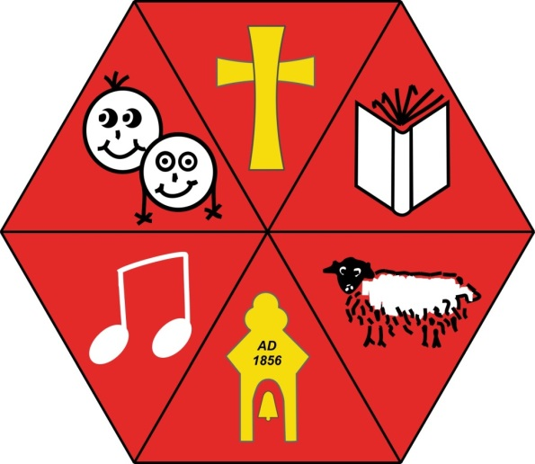

**Year 5**

**National Curriculum**

**Spelling Lists**

**National Curriculum Year 5 Spelling Lists**

**Autumn 1:**

|  |  |
| --- | --- |
| **Week 1**  father  believe  rough  excellent  accommodate  available  accompany | **Week 2**  possible  confident  soldier  twelfth  average  according  awkward |
| **Week 3**  language  definite  apparent  achieve  bargain  aggressive | **Week 4**  community  identity  vegetable  bruise  amateur  category |
| **Week 5**  tolerant  immediate  vicious  ancient  cemetery  apparent  committee | **Week 6**  changeable  advise  draught  appreciate  communicate  attached  community |

**Autumn 2:**

|  |  |
| --- | --- |
| **Week 1**  morning  explain  tough  persuade  competition  determined  conscience | **Week 2**  curious  assistant  familiar  programme  develop  conscious  dictionary |
| **Week 3**  bargain  system  thorough  controversy  disastrous  convenience | **Week 4**  mischief  rhyme  special  embarrass  correspond  environment |
| **Week 5**  precious  observation  substance  criticise  equipped  curiosity  equipment | **Week 6**  dependable  adorable  referred  definite  especially  desperate  exaggerate |

**National Curriculum Year 5 Spelling Lists**

**Spring 1:**

|  |  |
| --- | --- |
| **Week 1**  forty  steal  enough  terrible  excellent  hindrance  existence | **Week 2**  sensible  temperature  stomach  identity  explanation  immediate |
| **Week 3**  according  delicious  competition  familiar  immediately  foreign | **Week 4**  desperate  equipment  average  individual  forty  interfere |
| **Week 5**  frequent  restaurant  innocent  individual  harass  lightning | **Week 6**  incredible  independent  considerate  deceive  guarantee  leisure |

**Spring 2:**

|  |  |
| --- | --- |
| **Week 1**  cough  profit  disaster  practice  marvellous  persuade  mischievous | **Week 2**  especially  shoulder  recognise  lightning  physical  muscle  prejudice |
| **Week 3**  dictionary  artificial  achieve  necessary  privilege  neighbour  vegetable | **Week 4**  possibly  communicate  aggressive  profession  nuisance  programme  vehicle |
| **Week 5**  hesitate  applicable  preferred  occupy  pronunciation  occur  queue | **Week 6**  reference  neighbour  malicious  opportunity  recognise  parliament  recommend |

**National Curriculum Year 5 Spelling Lists**

**Summer 1:**

|  |  |
| --- | --- |
| **Week 1**  although  develop  exist  relevant  soldier  restaurant  stomach | **Week 2**  attached  desert  bruise  rhyme  sufficient  rhythm  suggest |
| **Week 3**  decent  further  symbol  sacrifice  symbol  secretary | **Week 4**  signature  profession  individual  system  shoulder  temperature  yacht |
| **Week 5**  occurred  government  obedient  noticeable  signature  thorough  sincere | **Week 6**  conceive  doubt  weary  confidential  twelfth  sincerely  variety |

**Summer 2:**

|  |  |
| --- | --- |
| **Week 1**  suggest  marvellous  reasonable  available  accompany  accommodate | **Week 2**  comb  confidence  accommodation  average  according  awkward |
| **Week 3**  island  secretary  sincere  embarrass  correspond  environment | **Week 4**  interfere  dough  relevant  especially  desperate  exaggerate |
| **Week 5**  physical  category  essential  proceed  familiar  immediately  foreign | **Week 6**  principle  stationery  compliment  environment  neighbour  profession  nuisance |