|  |  |  |
| --- | --- | --- |
| Aston and Cote CE Primary School – Knowledge Organiser 2023/2024 | | |
| Subject: Maths | Year 2 | Term 1 |

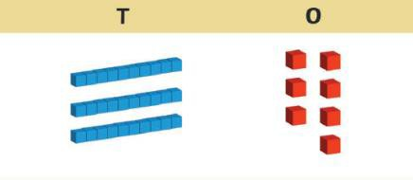

Place value is the number system that we use to describe the position and value of each digit within a number.

The number 12 has been put into place value columns below.

We can see that the number 12 has 1 ten and 2 ones.

**Remember: 1 ten is equal to 10 ones.**

**Challenge:** Find out the ages of people in your family and put them into place value columns.

If your mum is 37, you would lay it out like this:

**Place Value**

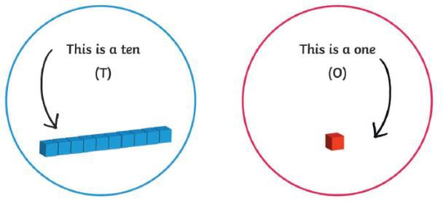

|  |  |
| --- | --- |
| **Tens** | **Ones** |
| **T** | **O** |
| **1** | **2** |

|  |  |
| --- | --- |
| **Tens** | **Ones** |
| **T** | **O** |
| **3** | **7** |

|  |  |
| --- | --- |
| **Shapes** | **x2, x5, x10** |
|  | 0 x 2 = 0 0 x 5 = 0 0 x 10 = 0  1 x 2 = 2 1 x 5 = 5 1 x 10 = 10  2 x 2 = 4 2 x 5 = 10 2 x 10 = 20  3 x 2 = 6 3 x 5 = 15 3 x 10 = 30  4 x 2 = 8 4 x 5 = 20 4 x 10 = 40  5 x 2 = 10 5 x 5 = 25 5 x 10 = 50  6 x 2 = 12 6 x 5 = 30 6 x 10 = 60  7 x 2 = 14 7 x 5 = 35 7 x 10 = 70  8 x 2 = 16 8 x 5 = 40 8 x 10 = 80  9 x 2 = 18 9 x 5 = 45 9 x 10 = 90  10 x 2 = 20 10 x 5 = 50 10 x 10 = 100  11 x 2 = 22 11 x 5 = 55 11 x 10 = 110  12 x 2 = 24 12 x 5 = 60 12 x 10 = 120 |

|  |  |
| --- | --- |
| **Number Bonds to 20** | |
| + = 20 | 20 - = |
| For Example:  11 + 9 = 20 | 20 - 8 = 12 |