Aston and Cote CE Primary School – Knowledge Organiser 2024/2025
Subject: English | Year 2 | Summer Term

Word Class Raps: | Spellings
Noun – A noun is a PPT, a person, place or thing. | Practice spelling these words:  Remember to use look, cover, write and then check using tick or fix.  today friend clothes  said here people  are when water  were house money  was because after  with our anyone  where would bought  there should caught  their could does
Adjective – An adjective describes a word; it tells us what it’s like.
Verb – A verb is a doing or a being word, if you do it or you are it then the word is a verb.
Adverb – An adverb describes a verb, it sometimes ends in –ly.
Can you create sentences and identify the word classes?
For example:
My ferocious dog was barking loudly.
Sentence Starters | Singular and Plural:
Can you come up with your own sentences using these sentence starters? | A singular noun means one person, one place, one thing or one idea.  A plural noun means more than one person, place, thing or idea. There are 6 main ways to change a noun from singular to plural.  Rule 1: most nouns add –s to the end of a word.  book – books desk – desks school – schools  Rule 2: Nouns that end in ‘ch’, ‘sh’, or ‘x’ add –es  bush – bushes box – boxes church – churches  Rule 3: Nouns that end in ‘f’ or ‘fe’ often change to –ves wife – wives  wolf – wolves  Rule 4: Some nouns change the inside letter  man – men goose – geese mouse – mice  Rule 5:Nouns that end in a consonant letter and y, drop the ‘y’ for an ‘i’ before adding –es  sky – skies puppy – puppies  Rule 6: Some nouns do not change  corn – corn fish – fish deer – deer  What sentences can you create using singular and plural nouns?  Challenge: Are there any exceptions to the rules?
Unlike…
Unlike most animals in the ocean, blue whales need to come up to the surface to get some air.
Don’t forget to…
Don’t forget to turn the lights off when you leave so we can help save the planet.
I found it interesting when…
I found it interesting when Mr Gum had a fairy living in his bathroom with a frying pan.
I was so surprised that…
I was so surprised that I fell off my chair when Mr Gray mentioned we were going on a school trip.
In a flash…
In a flash, Winston dashed across the field to get his ball.
Adding a Suffix:
A suffix is a group of letters that can be added to the end of a word to alter the meaning.
happy (adjective) – happiness (noun) run (verb) – runner (noun)
beauty (noun) – beautiful (adjective) help (noun) – helpless (adjective) quiet (adjective) – quietly (adverb)

Aston and Cote CE Primary School – Knowledge Organiser 2024/2025
Subject: Maths | Year 2 | Summer Term

Column Addition | Column Subtraction
Column addition uses the place value columns to make adding easier.  Remember:  -Always start with the ones  -One digit per column  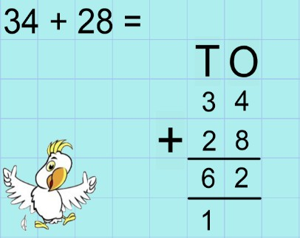  In the example above, we start by adding the ones column. 4 ones + 8 ones = 12 ones. 12 has 2 ones and 1 ten. We carry the extra ten underneath so that we  don’t forget to add it later. Next we add the tens. 3 tens  + 2 tens + 1 ten = 6 tens (60).  Can you try using column addition to add two 2 digit numbers? | Column subtraction uses the place value columns to make taking away easier.  Remember:  -Always start with the ones  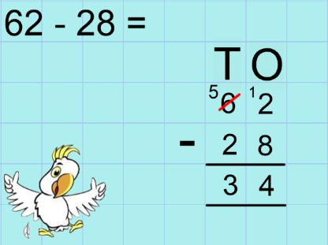  -One digit per column In the example above, we start by subtracting the ones column. But we can’t take 8 ones away from 2 ones, so  we have to exchange 1 ten for 10 ones. 12 ones – 8 ones = 4 ones. Next we subtract the tens. 5 tens – 2 tens = 3 tens (30).  Can you try using column subtraction to subtract two 2 digit numbers?

Fractions | Symmetry
The numerator is the top number that shows us how many equal parts we have.  The denominator is the bottom number that shows us how many equal parts the whole has been split in to.  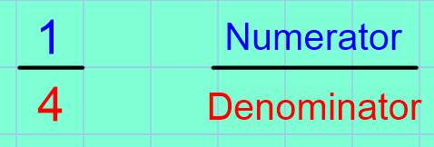  When finding fractions of amounts, we split the number by the denominator.  For example, if we are asked to find ¼ of 12, we need to split 12 into 4 equal groups because the denominator is 4.  12 shared into 4 equal groups has 3 in each group. 12 ÷ 4 = 3.  The numerator tells us how many groups we are looking at.  Can you find fractions of amounts at home? Why not try finding ¼ and ½ of these numbers: 4, 8, 12, 16, 20, 24, 28, 32, 36, 40, 44, 48 | Lines of symmetry may be horizontal, vertical or diagonal. Some 2D shapes will have no lines of symmetry and some 2D shapes will have multiple lines of symmetry.  Can you cut out or draw some different 2D shapes. Can you fold or draw on their lines of symmetry?  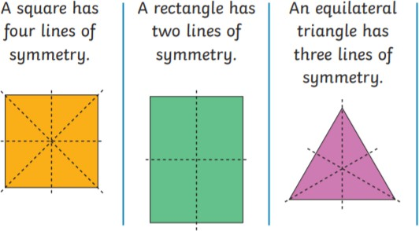  Symmetric figures  Patterns and shapes can be reflected in a mirror line. Mirror lines can be vertical, horizontal or diagonal.  On some squared paper, create your own symmetrical patterns. Use a mirror to check your patterns.  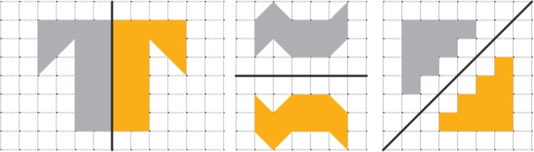

Less than (<) , Greater than (>)
< | >
For Example:  14 + 3 < 20  14g < 1kg  45 minutes < 1 hour | 20 – 5 > 10  5m > 100cm  2 minutes > 90 seconds

Time
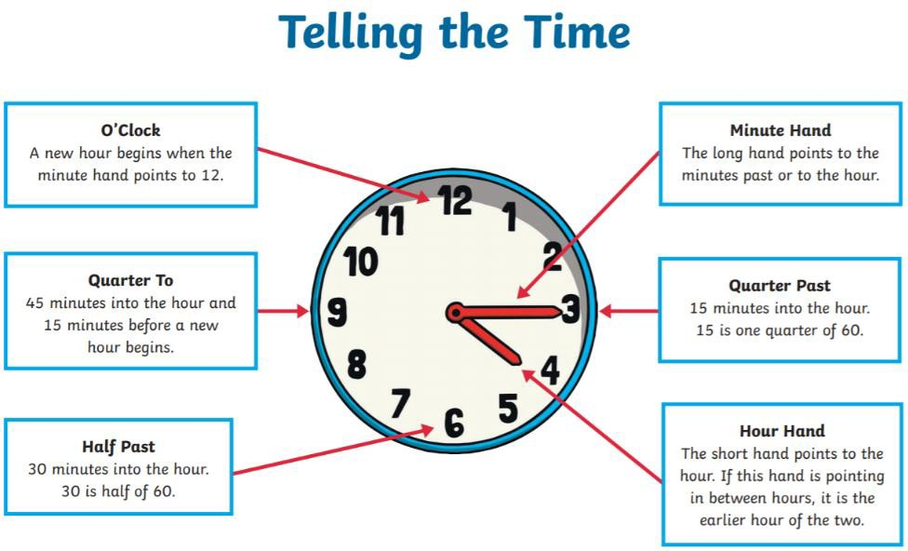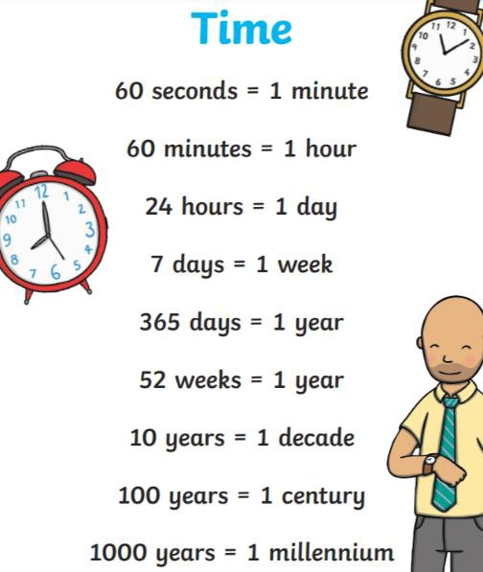

Equals
Equals (=) means the same as. The equals sign can appear in calculations in different ways. For example: 2 x 10 = 20
20 = 2 x 10
2 x 10 = 4 x 5
20 20
The value of each side of the = sign must be the same.
Can you write some number sentences using the equals sign in different positions?

x2, x3, x5, x10
0 x 2 = 0  1 x 2 = 2  2 x 2 = 4  3 x 2 = 6  4 x 2 = 8  5 x 2 = 10  6 x 2 = 12  7 x 2 = 14  8 x 2 = 16  9 x 2 = 18  10 x 2 = 20  11 x 2 = 22  12 x 2 = 24 | 0 x 5 = 0  1 x 5 = 5  2 x 5 = 10  3 x 5 = 15  4 x 5 = 20  5 x 5 = 25  6 x 5 = 30  7 x 5 = 35  8 x 5 = 40  9 x 5 = 45  10 x 5 = 50  11 x 5 = 55  12 x 5 = 60 | 0 x 10 = 0  1 x 10 = 10  2 x 10 = 20  3 x 10 = 30  4 x 10 = 40  5 x 10 = 50  6 x 10 = 60  7 x 10 = 70  8 x 10 = 80  9 x 10 = 90  10 x 10 = 100  11 x 10 = 110  12 x 10 = 120 | 0 x 3 = 0  1 x 3 = 3  2 x 3 = 6  3 x 3 = 9  4 x 3 = 12  5 x 3 = 15  6 x 3 = 18  7 x 3 = 21  8 x 3 = 24  9 x 3 = 27  10 x 3 = 30  11 x 3 = 33  12 x 3 = 36

Inverse
The Inverse of addition is subtraction.  If I know that 2 + 6 = 8, then I know that 8 – 2 = 6.  If I know that 12 – 5 = 7, then I know that 5 + 7 = 12. | The inverse of multiplication is division  If I know that 4 x 2 = 8, then I know that 8 ÷ 2 = 4.  If I know that 30 ÷ 5 = 6, then I know that 6 x 5 = 30.
Can you write some number sentences and show us the inverse as well?
If I know , then I know .

2D Shapes | 3D Shapes
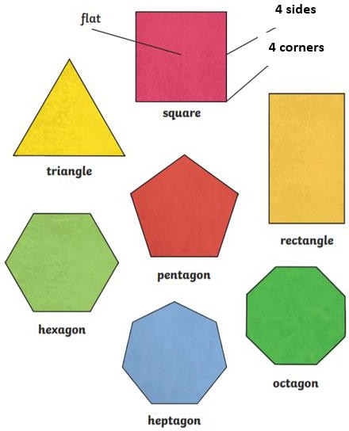 | 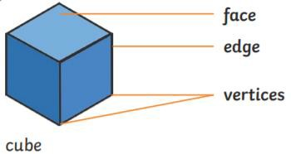  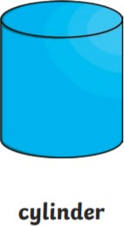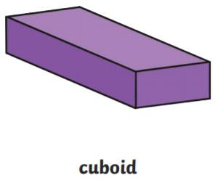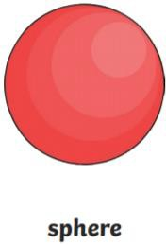  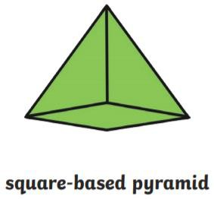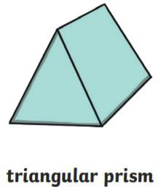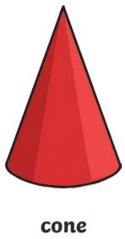  Can you describe these shapes using faces, edges and vertices?

Money
Using the coins and notes, can you make your own number sentences and word problems?
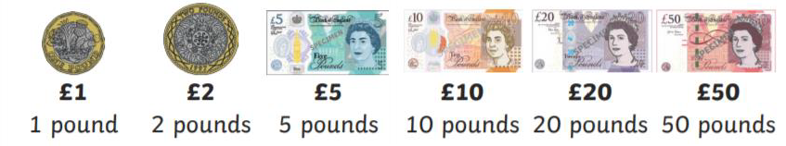
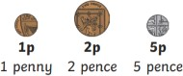
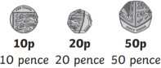
For example:
Mr Abracadabra buys 2 books that cost
£5 each. He pays with a £20 note. How Much Change will he get?
Measurement
We measure length in centimetres and metres. The prefix ‘centi’ means 100.
100cm = 1m
We measure volume and capacity in millilitres and litres. The prefix ‘milli’ means 1000.
1000ml = 1l
We measure mass in grams and kilograms. The prefix ‘kilo’ means 1000.
1000g = 1kg.
We measure temperature in degrees Celsius.
Water freezes at 0ºC. It is 18ºC today.

