Column Addition | Column Subtraction
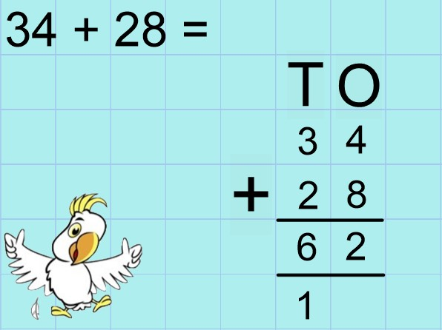  Column addition uses the place value columns to make adding easier.  Remember:  - Always start with the ones  - One digit per column  In the example above, we start by adding the ones column. 4 ones + 8 ones = 12 ones. 12 has 2 ones and 1 ten. We regroup the extra ten underneath so that we  don’t forget to add it later. Next we add the tens. 3 tens  + 2 tens + 1 ten = 6 tens (60).  Can you try using column addition to add two 2 digit numbers? | 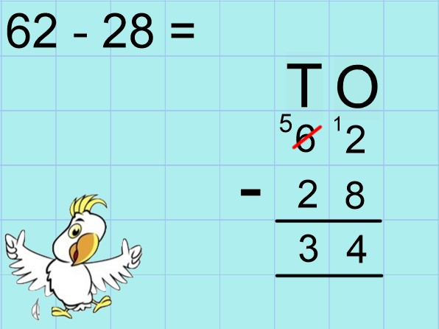  Column subtraction uses the place value columns to make taking away easier.  Remember:  - Always start with the ones  - One digit per column  In the example above, we start by subtracting the ones column. But we can’t take 8 ones away from 2 ones, so we have to exchange 1 ten for 10 ones. 12 ones – 8 ones = 4 ones. Next we subtract the tens. 5 tens – 2 tens = 3 tens (30).  Can you try using column subtraction to subtract two 2 digit numbers?
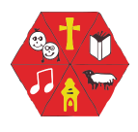

x2, x5, x10 | Odds and Evens
0 x 2 = 0 0 x 5 = 0 0 x 10 = 0  1 x 2 = 2 1 x 5 = 5 1 x 10 = 10  2 x 2 = 4 2 x 5 = 10 2 x 10 = 20  3 x 2 = 6 3 x 5 = 15 3 x 10 = 30  4 x 2 = 8 4 x 5 = 20 4 x 10 = 40  5 x 2 = 10 5 x 5 = 25 5 x 10 = 50  6 x 2 = 12 6 x 5 = 30 6 x 10 = 60  7 x 2 = 14 7 x 5 = 35 7 x 10 = 70  8 x 2 = 16 8 x 5 = 40 8 x 10 = 80  9 x 2 = 18 9 x 5 = 45 9 x 10 = 90  10 x 2 = 20 10 x 5 = 50 10 x 10 = 100  11 x 2 = 22 11 x 5 = 55 11 x 10 = 110  12 x 2 = 24 12 x 5 = 60 12 x 10 = 120 | There was a farmer who had a pig And EVEN was his name-o.  0-2-4-6-8  0-2-4-6-8  0-2-4-6-8  And EVEN was his name-o!  There was a farmer who had cow And ODD was her name-o.  1-3-5-7-9  1-3-5-7-9  1-3-5-7-9  And ODD was her name-o  Can you write some numbers and work out if they are odd or even?  How many tens and ones does the number have?

Less than (<) , Greater than (>)
< | >
For Example:  14 < 15 | 25 > 24

Phonics | Spellings
Practice reading and writing these phonemes (sounds). | Practice spelling these words:  Remember to use look, cover, write and then check using tick or fix.  friend school house  our door floor  poor because find  kind mind behind  child children wild  climb most only  both old cold
ea – cup of tea are – care and share
oi – spoil the boy ur – nurse with a purse
a-e - make a cake er – better letter
i-e – nice smile ow – brown cow
o-e – phone home ai – snail in the rain
u-e – huge brute oa – goat in a boat
aw – yawn at dawn ew – chew the stew
Can you find more words that use these sounds?
Word Class | Punctuation
Noun: | Capital letters are used:  - At the start of a sentence:  We went for a trip to the supermarket.  - For proper nouns like names of people and places:  Hannah Thomas Africa Big Ben  - Days of the Week and Months of the Year:  Monday October  Full stops are used at the end of a sentence: The monster roared loudly.  The giraffe was eating the leaves.  Can you try writing your own sentences including the correct punctuation?
A noun is a PPT, a person place or thing.
Example:
I live in Swindon.
My favourite food is spaghetti.
Lily is my best friend.
Adjective:
An adjective describes a word; it tells us what it’s like.
Example:
The weight is quite light.
I like your blue dress.
Lily’s hair is very long
Verb:
A verb is a doing or a being word. If you do it or you are it
then the word is a verb.
Example:
Could you light the candle please
I love reading.
I’m going to the park.
Can you use these sentence starters to create your own sentences?
Starting sentences with a verb:  - Don’t . . .  - Go on . . .  - Try a . . .  - Enjoy the . . .  - Imagine . . .  - Take a moment to . . .  - Find out . . .  For example,  Enjoy the holiday, you deserve the break. Go on, have another sweet!  Imagine how nice it would be if it snowed on Christmas. | Adverbs to start a sentence with:  - Hopefully  - Fortunately  - Unfortunately  - Luckily  - Unluckily  - Thankfully  - Lately  For example,  Curiously they waited to see what was behind the magical door.  Lately I have been feeling extremely tired.

